A Chronological Perspective on the Studies of Turkisms Conducted in Balkan Languages

Author : Doğan YÜCEL

Abstract

Turkisms in the Balkan languages ​​continue to be an essential research subject since Karadzic published the first Serbian Dictionary in 1818. Turkisms studies have been compared to countries where the studies were published, the researchers' nationalities, and the studies' languages in tables. We have evaluated total of 1392 research in this study. Turkism researchers published the highest number of studies in the Turkish and Bulgarian languages. Turkisms in six Balkan languages ​​were published in 17 languages ​​by researchers from 21 nationalities in 35 different countries. While evaluating the studies, they have been handled in five different periods according to the Balkans' significant political events during the last two centuries. We have classified studies according to 33 subtitles under four categories. These four categories are detection and collecting, classification, evaluation and analysis, and current frequency measurement and revitalization of Turkisms. The method used in this study is the same as the method used by Yücel in his six published bibliography studies. Turkism studies classified are based in this study on Yücel's six studies given in the bibliography.

Key words: Turkisms, Balkan languages, Turkish Loanwords.

Introduction
Turkish language became a "superstratum" from time to time from the Huns until the Ottoman Empire entered into the Balkans. An uninterrupted Ottoman-Turkish administration took place roughly between the 14-19th centuries in the Balkans. During this administration period, the Turkish language carried both original lexical elements and elements of oriental languages ​​such as Arabic, Persian, Chinese and Mongolian, and Western languages ​​such as Greek, Italian, and Hungarian in Balkan languages. In this period, Turkish influenced Balkan languages ​​in terms of words and lexical elements and received significant words and lexical elements from these languages. (Tietze, Süleymanoğlu-Yenisoy). Another essential function of the Turkish language in this period being a bridge language between Balkan languages. In this way, the Turkish language carried some Balkan language elements ​ to other Balkan languages (Nasteva, 70). However, in terms of quantity, the words and elements borrowed from Turkish to Balkan languages ​​are much more than words and elements borrowed from Balkan languages ​​to Turkish.
The course of the borrowed words from Turkish to Balkan languages ​​ (which is called Turkism in Balkan Languages) is determined in two ways in the Ottoman period. First, published religious and literary texts in Balkan languages ​​under Ottoman rule (Graham, 2015); the second one is the single and multilingual dictionaries of Balkan languages ​​written in this period. Such as Frang Bardhi in 1635 and the Makbul-i Arifi of Potur Shahidi in 1631. Some small word lists written with definitions such as "unknown words / foreign words / rarely known words" at the end of some books in the Balkan languages ​​before Karadzic's dictionary (Karasu, 2017). There are many studies of this said period's literary works. One of them is "Relations between Balkan Languages and Turkish Language and Culture (Serbian-Macedonian-Bulgarian) throughout History" prepared by Karasu in 2014. There are more studies found on this subject in the bibliography. Turkisms studies started in the middle of the 19th century independently. Later on, these studies continued by gaining momentum and increased, and have reached today. The amounts of studies and their classifications according to the subheadings given in tables in this study.
Turkism researchers have conducted many studies on Turkish loanwords and elements borrowed into Balkan languages ​​both in pre-Ottoman and Ottoman periods. These studies have been gathered sometimes as bibliography studies to facilitate bibliographical easiness for future researchers. We want to tell some important research works of these briefly in chronological order. In 1956, Hraste's "Bibliography of studies published in Serbian-Croatian dialectology, anthropology, toponym, and hydronium," in 1971 Stachowski's "Studia nad chronologią turcyzmów w języku bułgarskim" (studies on the chronology of Turkisms in Bulgarian), in 1993 Petrovich's work, which is later published as a paper, in 1995 by Kutlar-Aksel's master thesis titled "Turkish Culture Words in Balkan Languages" added as "Bibliography of Studies on the Subject," consisting Western languages ​​such as Russian, Hungarian and Polish, and Kutlar's paper in 1999, "Short Bibliography on Turkish Borrowings and Dictionaries in the Balkan Countries," including Russian and Hungarian. Out of the 140 studies, 15 of them on Turkisms in Bulgarian, 5 of them in Macedonian, 3 of them in Greek, 16 of them in Romanian are related to this study in Kutlar's paper. In 2010, Ahmetaj has listed 990 master's and doctoral theses in Turkey, named "Thesis Bibliography Written in Turkey on Balkans." In his study, there are no studies on Turkisms in Macedonian, Greek, and Romanian among 87 papers under Macedonia, 261 under Greece, and 22 papers under Romania, and only two of 62 theses on Albania are about Turkisms in Albanian. In 2019 Uzun and Özek wrote one paper titled "Studies in Turkey Related to Balkans I" and consisted of 519 papers written on Balkans in Turkey. They classified these studies according to titles as Balkan countries and topics (grammar, texts, dictionaries, and other studies). In this paper of Uzun and Özek, 98 studies under the heading of Bulgaria, 18 of them on Turkisms in Bulgarian; 70 studies under Macedonian title, 10 of them on Turkisms in Macedonian; 38 studies under heading Romanian, eight of them on Turkisms in Romanian; under the headings of General Studies on Albania, Balkans/Rumelia and Kosovo, 17 studies of 186 Turkisms in Albanian are related to our research. There are seven studies under the title of Greece and no study on Turkisms in Greek. In 2019, Uzun published one another paper with the same name and the same method. In her article, independent books besides master's and doctoral theses are listed. Among 398 studies mentioned in Uzun's paper, 15 of 83 Turkisms in Bulgarian under the heading of Bulgaria; 39 on Turkisms in Macedonian under heading Macedonia; 3 of 40 studies on Turkisms in Greek under heading Greece; 2 studies on Turkisms in 11 Romanian under subtitle Romania; there are seven studies of 114 on Turkisms in Albanian under general studies on Albania, Balkans/Rumelia and Kosovo. In 2015, Aksoy penned a paper named "A Study of bibliography Related on Bosnia and Herzegovina and the Bosnian Culture Made in Turkey" and collected 71 studies in his paper.
Recently, Yücel has prepared separate bibliographic studies for the six Balkan languages ​​using the same method for each study. The works in these studies are sub-titled and translated into Turkish. Eight hundred ninety-four studies, 275 on the borrowing factors and research sources of the compilation of Turkisms in Serbian-Croatian-Bosnian language, and 619 on direct or indirect Turkisms studies collected in this study. As for the other Balkan languages, Bulgarian is 222 and 472, Albanian 114 and 297, Macedonian 70 and 237, and Greek is 56 and 140, and Romanian is 70 and 199. Eight hundred seven on borrowing factors and research sources and 1964 studies on direct or indirect Turkisms studies listed in six Balkan languages. As a result, 1955 studies considered excluding ten out of 1964 studies and included one more study. Some studies related to more than one Balkan language when considered as a single study, and then the actual number is 1392. We gave all figures of studies in the below tables.

  - The Aim and Method of the Study

Six studies of Yücel (in terms of the unity of method) given in the bibliography were considered the basis of this work. 1955 (1392) works mentioned in these studies were classified according to the method used in Yücel's articles. These 33 sub-headings in four categories are as follows;
1. Detection and compilation
1.1. Turkism Compilations
1.1.1. Direct Compilation Studies
1.1.2. Thematic Compilations
1.1.3. Author / Work Compilations
1.2. Indirect Turkism Studies
1.2.1. Loanwords Dictionaries
1.2.2. Borrowing Process Studies
1.2.3. Linguistics, Methodology and Interlinguas Studies
1.2.4. The Widening of Turkisms from Balkan Languages to Other Languages

2. Classification
2.1. Word Classifications
2.1.1. Etymology
2.1.2. Turkish Loanwords from Other Languages to Balkan Languages Apart Than Turkish Origin.
2.1.3. Thematic
2.1.4. Word Types
2.1.5. Toponymical, hydronym, fitonym etc.
2.1.6. Anthropology, onomastic.
2.1.7. Turkisms in Dialects of Balkan Languages
2.2. Language Quelques
2.3. Lexical Elements
2.3.1. Idioms and Phrasal verbs
2.3.2. Suffixes
2.3.3. Exclamations

3. Evaluation and Analysis Studies of Turkisms
3.1. Word Analysis
3.1.1. Etymological
3.1.2. Phonetic
3.1.3. Morphological
3.1.4. Semantics
3.2. Lexical Elements
3.2.1. Idioms, Proverbs, etc.
3.2.2. Suffixes
3.3. Book Reviews and Analysis
3.4. Socio-Linguistics Analysis of Turkisms
3.5. Spelling and Orthography Issues of Turkisms in Balkan Languages
3.6. Pronunciation Issues of Turkisms in Balkan Languages

4. Current Frequency and Revival of Turkisms
4.1. Current Frequency of Turkism in Balkan Languages (literary products etc.)
4.2. Process and Reasons of Archaism and Fall from Use in Balkan Languages of Turkisms
4.3. Recently Produced Turkisms After Ottoman.
4.4. Research on Revitalizing Turkisms and Increasing Uses of Turkisms.
4.5. Current Frequency Measurement of Balkan Turkisms (Yücel, 2020: 4545).

The studies, categorized in the four steps, have been arranged according to the significant historical events in the Balkans since 1818, from Karadzic's dictionary. 1. Period: 1818-1878 the period from the lexicon of Karadzic to the Ottoman-Russian war. 2. Period: 1879-1918 The periods from the Ottoman-Russian War to the end of the First World War. 3. Period: 1919-1945 The period from the end of the First World War to the Second World War. 4. Period: 1945-1991 The communism periods in the Balkans. 5. Period: 1991-2020 The new periods after communism in the Balkans.
The studies have been considered in the tables according to the four-step classification and periods determined above. First, studies are ordered six Balkan languages in a general table according to periods. The second table shows the Turkism studies according to their languages. The third table determines the nationality of the Turkism researchers. The fourth table shows the countries where Turkism studies were published, and finally, in the fifth table (excluding duplicates) with a tripartite classification in the form of language-nationality-country. The interpretations of the tables have been made for each of them separately.

Findings and Interpretations
The findings obtained in terms of language, country, and nationality of Turkisms researchers in six Balkan languages are shown in tables, and the author of this study have interpreted each table.

2.1. General Chronological Overview of the Studies in Terms of Languages

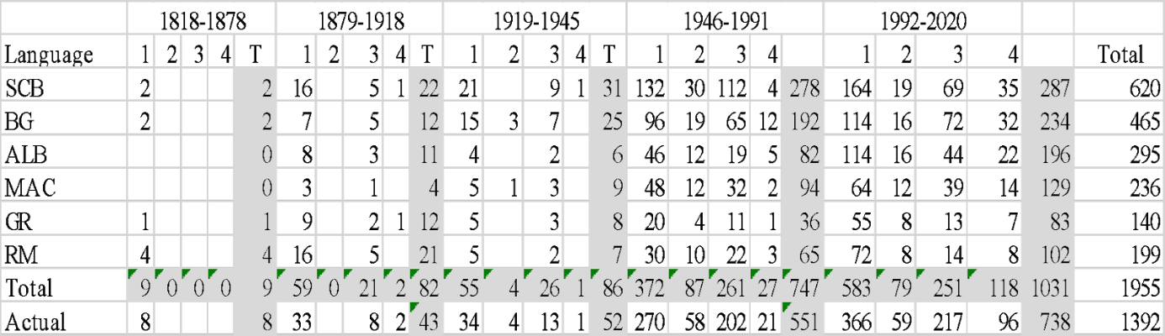
It is seen in the above table that an increase in both study types and the number of studies in recent years. More than half of the works so far have been done recently. However, there is closeness in the number of SCB and Bulgarian studies in the last two periods. The fourth period is 45 years and the last period is 30 years, while in the fourth period, an average of 10 studies per year in these two languages and 18 in the last period. When duplicates have been removed, the average is 0.13 in the first period, 1.07 in the second period, 1.92 in the third period, 11.97 in the fourth period, and 25.44 in the last period. The research of Turkisms in Balkan languages ​​is receiving more attention year and year by researchers. The interesting fact that there is almost no study in the first, second, and third periods in Macedonian and Albanian (MAC: 19, ALB: 17). This issue can be attributed to the later separation of the lands where these two languages ​​are spoken from the Ottoman empire compared to other Balkan languages. The maximum number of studies conducted regarding the compilation, detection, and borrowing process is 711/1392 (51%).

2.2. Distribution of Balkan Languages in which Studies are published by Subject and Periods
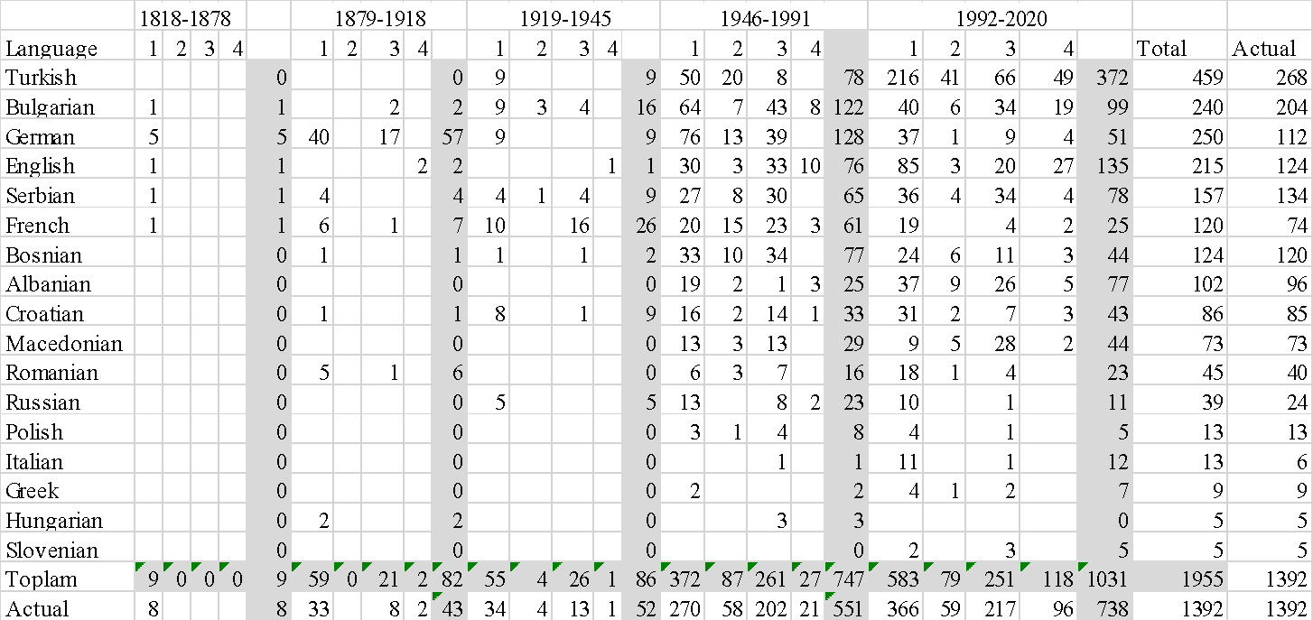
Considering the languages of Turkism studies were published, six Balkan languages and Turkish (1029/1392, 74%) constitute three-quarters of the total number of studies. There is no study in languages ​​other than European languages. Considering Serbian, Croatian, and Bosnian as one language, it constitutes one-fourth of all studies with 334 studies. Except for the six Balkan languages ​​and Turkish, the highest number of studies penned in English, French, and German. In the first, second, and fourth terms, German, in the third term French was the first language preferred by Turkism researchers, other than Balkan languages ​​and Turkish. The differences in the values ​​in the last two columns, which are close to each other, are concentrated only in one language. The last column shows the actual number of studies. The other column next to the last shows studies involving more than one Balkan language—the studies published in Turkish and German cover many languages compared to others. In contrast, the studies covering one language are more intense in languages ​​such as Romanian, Macedonian, Greek, and Albanian.

2.3. Distribution of Nationalities of Turkism Researchers by Subject and Periods

When looking at the researchers' nationalities who published studies on Turkisms in Balkan languages, some interesting points are immediately apparent. The author's number of studies does not show the researchers' real number. Turkish researchers published their studies mostly in recent years. There is no Macedonian and Albanian researcher in the first three periods. Serbian, Croatian, and Bosnian researchers hold 28% of the total number of researchers together.

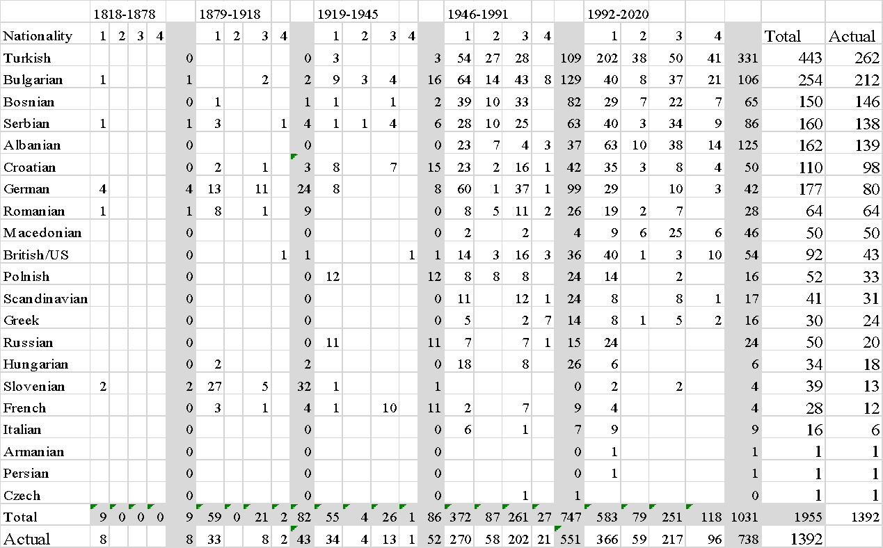

We see in the table that researchers from 21 different nationalities published their studies on this subject. Almost all of the researchers are from the European continent. The last two columns determine that Romanian and Macedonian researchers have done all their work on a single Balkan language. This situation changes drastically in German and Turkish authors.

2.4. Distribution of Turkism Studies by Countries Published in Topics and Periods

30 of the 35 countries in the table are from the European continent. The countries are considered where the studies were published according to their current day borders. Researchers published their studies 98% in the European continent. Turkey, Bulgaria, and Serbia are the host of the highest number of Turkism studies. While English is the preferred language in 124 studies, the number of British / American authors is 43, and the number of studies published in England, New Zealand, Canada, and the USA are 32. This figure may mean Turkism researchers wrote some of their research in English other than their mother language and native countries. German and French languages are also similar to English in this case.

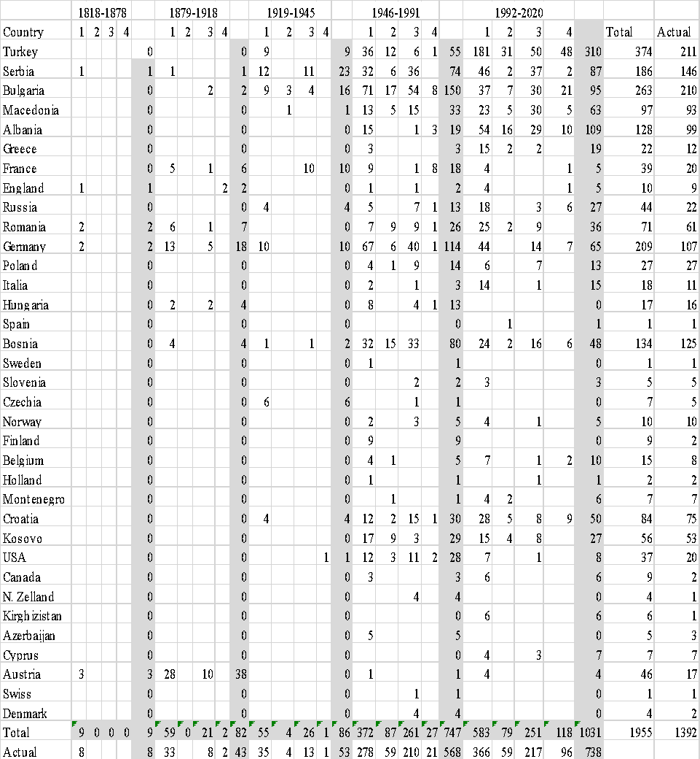

2.5. Comparison Table for the Countries of Publications, Nationalities of Researchers, and the Languages of Studies

When country, nationality, and language tables are gathered together in terms of the periods, the studies' historical course may be seen more clearly by anybody. When consider the Turkish researchers who are published 187 of 262 studies in their mother language, it is understood that Turkism researchers prefer their mother languages in three-quarters of their all researches. Language, country, and nationality comparisons can also be seen by looking at the table.
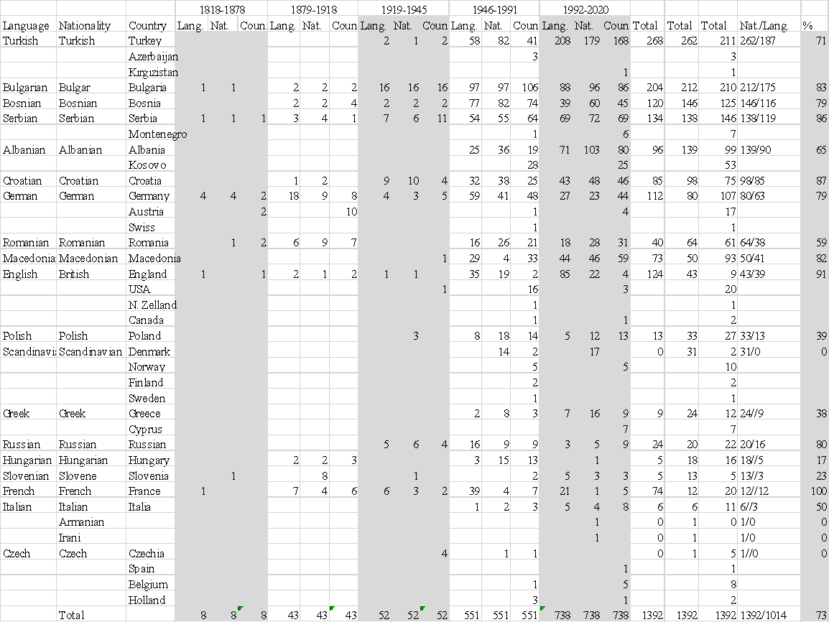

If researchers who wrote on Romanian and Greek excluded, researches published on this subject in the Balkans in more than 80% of the researchers' native countries.

Conclusion
In the last two centuries after Karadzic's dictionary, studies on Turkisms in six Balkan languages ​​have been classified in this study according to languages, nationalities of researchers, and the countries where they are published. Studies on the subject can compare by countries, languages, and nationalities of the researchers according to five periods within the determined historical course. In the historical process, the subject's rates in terms of nationality, country, and language have become visible now. According to the five periods determined, the reasons for the increase and decrease in the studies' table values ​​may open doors for new studies. Another interesting point is that studies in Macedonia, Albania, and Turkey have started Turkism studies late compared to other Balkan countries. We have presented numerical data for determining subtitles in this study and the study types during the historical course. The results of the four-step method determined in the study have been presented to the world of science in numerical data.

References
Ahmetaj, M. (2010). Balkanlara Yönelik Türkiye’de Yapılan Tezler Bibliyografyası. Balkan Araştırmaları Dergisi, (1)2, Ek.
Aksoy, Ö. (2015). Bosna Hersek ve Boşnak Kültürü ile İlgili Türkiye'de Yapılan Çalışmalar Üzerine Bir Bibliyografya Denemesi, Trakya Üniversitesi Edebiyat Fakültesi Dergisi. (5)10, 111-129.

Hraste, M. (1956). Bibliografija radova iz dijalektologije, antroponimije, toponimije i hidronimije na području hrvatskoga i srpskoga jezika. Hrvatski dijalektološki zbornik. 1, 387-479.
Kutlar, H. (1999). Balkan Ülkelerindeki Türkçe Alıntılar ve Sözlükler Üzerine Kısa Kaynakça. Kebikeç, 4(7-8), 85-93.
Petrović, S. (1993). Istorijat i stanje proucavanja turcizama u srpskohrvatskom jeziku. (Unpublished Master Thesis). Belgrad Üniversitesi Filoloji Fakültesi Doğu Dilleri ve Edebiyatları Bölümü, Belgrad.
Petrović, S. (1993). Историjaт и стане проучвана Турцизма у српско-хрватском Jезику. (Istorijat u stanje proučavana Turcizma u Srpsko-Hrvatskom Jeziku). Зборник за филологиjу и лингвистику, XXXVI (2), 71–128.
Uzun, C. & Özek, F. (2019). Balkanlarla ilgili Türkiye’de yapılmış çalışmalar-I. Çukurova Araştırmaları, 5(1), 22-52. DOI: 10.18560/cukurova.1117
Uzun, C. (2019). Balkanlarla ilgili Türkiye’de yapılmış çalışmalar-II. Çukurova Araştırmaları, 5(2), 150-178. DOI: 10.18560/cukurova.1148
Yücel, D. (2020). Arnavut Dilindeki Türkizmler Üzerine Yapılan Çalışmalara Bir Çerçeve, Değerlendirme Ve Kaynakça Denemesi. Asos Journal Akademik Sosyal Araştırmalar Dergisi, 8(104), 193-230. DOI: http://dx.doi.org/10.29228/ASOS.41998 ISSN: 2148-2489
Yücel, D. (2020). Bulgar Dilindeki Türkizmler Üzerine Yapılan Çalışmalara Bir Çerçeve, Değerlendirme Ve Kaynakça Denemesi. Akademik Sosyal Araştırmalar Dergisi, 7(46), 380-419. Doi:http://dx.doi.org/10.29228/SOBIDER.43372 ISSN: 2149-0821
Yücel, D. (2020). Makedon Dilindeki Türkizmler Üzerine Yapılan Çalışmalara Bir Çerçeve, Değerlendirme Ve Kaynakça Denemesi. Kesit Akademi Dergisi, 7 (26), 182-213. DOI: 10.29228/kesit.49221
Yücel, D. (2020). Romencedeki Türkizmler Üzerine Yapılan Çalışmalara Bir Çerçeve, Değerlendirme Ve Kaynakça Denemesi. Journal of Research in Turkic Languages, 2(1), 21-52. DOI: 10.31757/jrtl.212
Yücel, D. (2020). Sırp-Hırvat-Boşnak Dilindeki Türkizmler Üzerine Yapılan Çalışmalara Bir Çerçeve, Değerlendirme Ve Kaynakça Denemesi. Akademik Sosyal Araştırmalar Dergisi, 7(46), 650-698.
Doi Number: http://dx.doi.org/10.29228/SOBIDER.42943 ISSN: 2149-0821
Yücel, D. (2020). Yunancadaki Türkizmler Üzerine Yapılan Çalışmalara Bir Çerçeve, Değerlendirme Ve Kaynakça Denemesi. The Journal of Kesit Academy, 6(23), 169-197. DOI: 10.29228/kesit.42829 ISSN: 2149 – 9225.
Tietze, A. (1983). The Present State of the Study of Turkisms in the Languages of the Mediterranean and of the Balkan Peninsula. Mediterranean Language Review, 1, 15-26. DOI: 10.13173/medilangrevi.1.1983.0015

