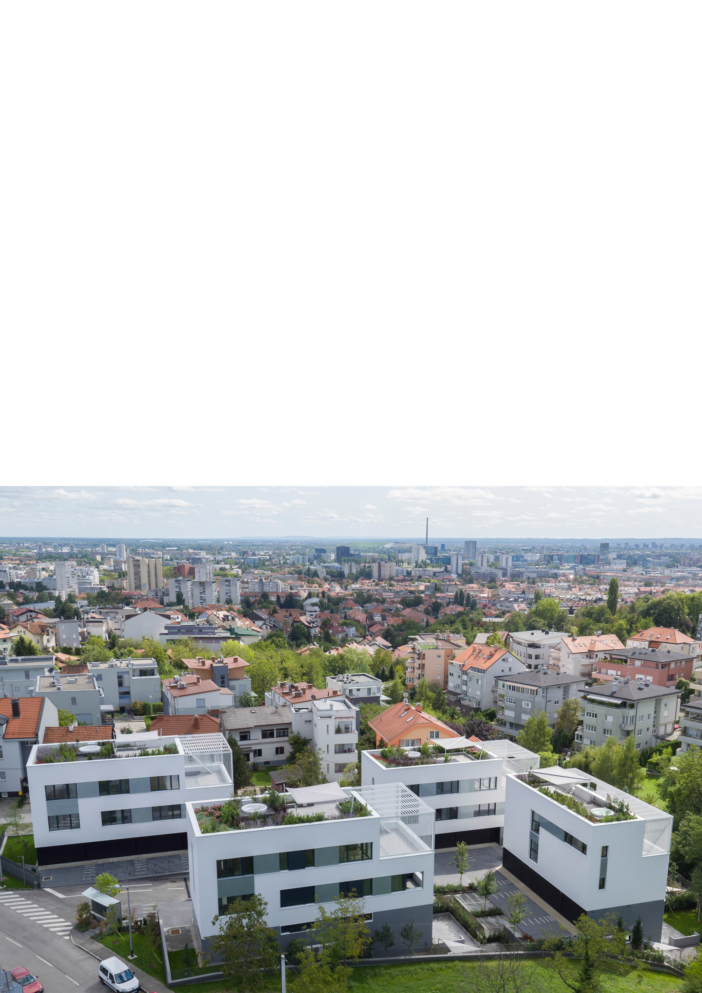

RESI DENTIAL COMPLEX JOR DANOVAC, ZAGREB
AUTHORS: LUKA KORLAET & ARCHITECTURE SVEBOR ANDREJEVIC

TH E RETURN OF THE MODERN
The new residential design brings back the spirit of Le Corbusier Photography by: Miljenko Bernfest, Luka Korlaet

CONTEXT

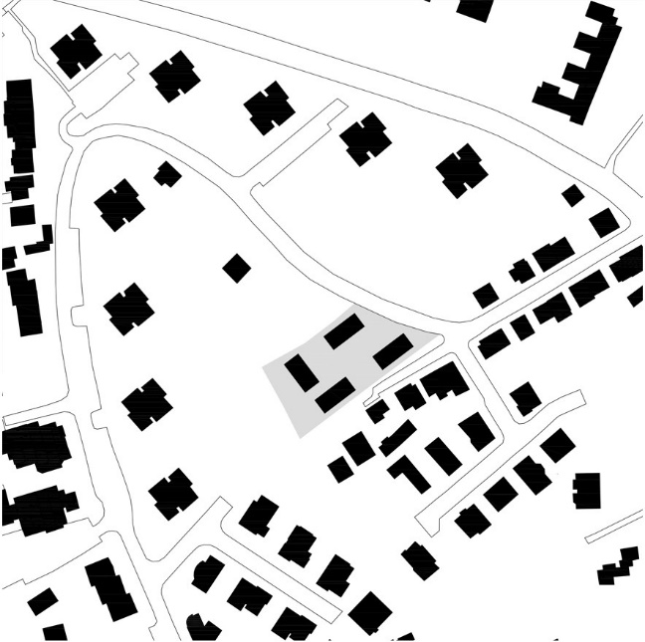
The second half of nineties and twenties were the building Eldorado: the bank loans were shared without any delays to entrepreneurs and apartment buyers. It was built a lot and very uncertainly. Speaking of Zagreb, the slopes of Medvenice were especial ly attractive. That space was built with numerous urban vil las, the smal l multi-storey buildings, which its investors and architects were led by exploation logic and rarely think about quality of floor plans or about environment between buildings.
The crisis between 2008-2018 has brought the need for changes: due to credit restraints on the one hand and the satiation of the built space on the other hand, it was necessary to find completely new modes of action, both in the investor and in designing sphere. Devoted investors in col laboration with architects, have come up with fresh sol utions that take in consideration the long­ neglected space in between buildings, the adaptability of residential floor plans, and ultimately energy efficiency and smart equipment.
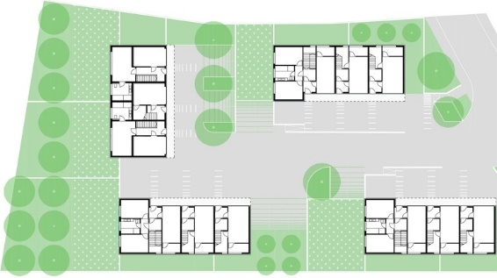
The residential complex Jordanovac is the result of such a new way of thinking about the residential community. It is designed by the beninning of the crisis ( 2010-11.), it combines several long-neglected topics such as: great attention is dedicated to the interspace of buildings; apartments are designed as a multi­ storey maisonettes by which they are approaching to the ideal of family house; the exterior spaces of apartments are diverse (gardens, terraces, loggia, roof gardens, etc.) and richly dimensioned. Finally, the houses are extremely energy efficient and use alternative energy sources.

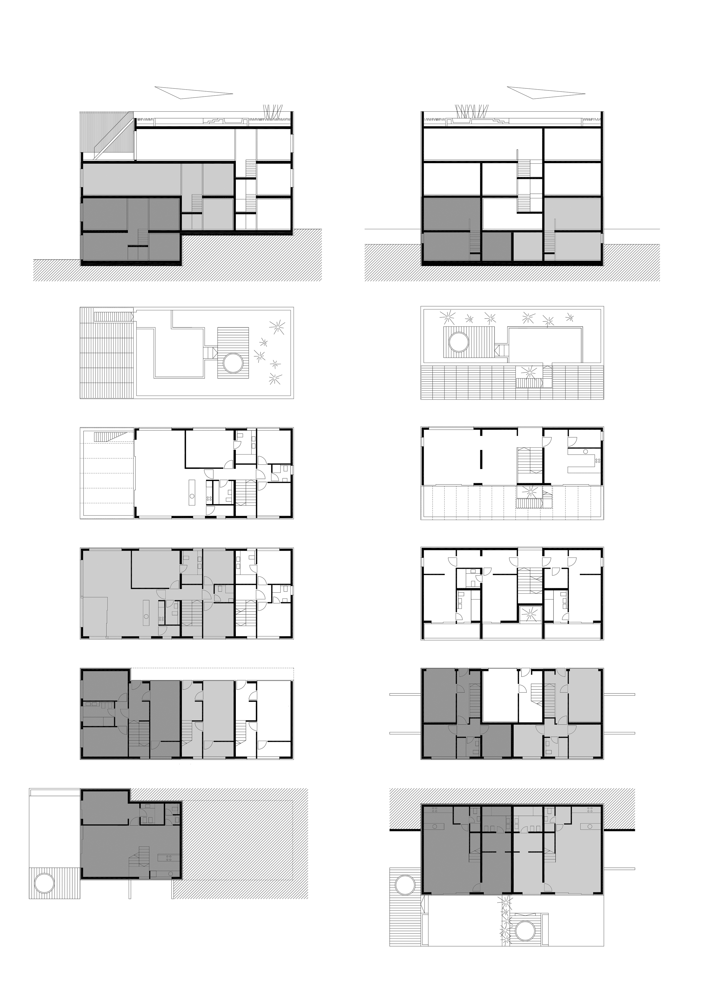

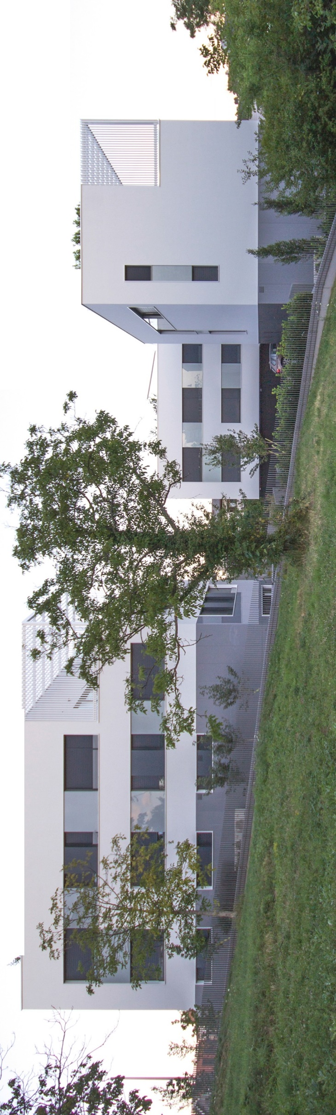
•,
r

CONCEPT

The residential complex of four buildings is located in Jordanovac (Zagreb), in the contact zone of family building and residential towers from the mid-seventies, designed by architect Aleksandar Bakal.

By adopting these boundary conditions, we design the measurement, the transitional type and shape of the building and gather them around the semi-private yard intended for access, association and play. By selection of materials and horticultural arrangement of environment, we try to humanize and domesticize. Boundaries between the access path and individual particles are invisible. The pavement is carefully designed and covered with greenery, by prisms in light tones - with small zebra crossings, we suggest the pedestrian entrances. By selection of vegetation, we strive to move away from their usual treatment, color and type. An important role in the design of the environment has the 'fifth elevation' or roofs. A view at them from the surrounding buildings provides the visual pleasure and annuls the negative effects of construction. The adequate attention is also devoted to the fences of residential complex, a series of dark gray verticals without the upper horizontal link or handrail that is trying to act transparently and discretely, unobtrusively.
The complex is consisted of two types of buildings - three similar/mirrored ones, placed vertically on the sides and one that is placed parallel to them. In design sense, the houses are simple prisms with that are smoothly plastered on the plinth from large- format glassware or the fiber optic boards. The windows are large with low parapets of equal dimensions and at the same intervals. This form is a reference on Zagreb's Modern architecture between the two world wars but, of course, in a contemporary interpretation. The windows of each apartment are united by plywood, while their gap is united by the glass in light gray tone. The 'reading' of the front thus becomes the dually semantical. The observer has a clear order (characteristic of the already mentioned Modern architecture of Zagreb), but united elements (plywood and glass) give a clear indication of the section of the inner structure of the building. By the general urban plan of Zagreb, the terraces of recessed floor are defined which are covered with the pergolas made of galvanized steel cabinet profiles.

Each building contains three apartments. Each apartment is provided by a direct pedestrian and walk access. Apartments have more floors and space quality of small family houses which are three-sided or even four-sided oriented. They are combined with large openings that make the apartment well illuminated and radiated. Different sizes of apartments are offered, such as 125, 150, 200 and 250m2 of neto of useful area. The structural features of the building ( longitudinally reinforced concrete walls in the range of 8 meters) have made apartments very flexible. Al l the walls within the floor plan are partition walls that come in numerous scenarios, in terms of arrangement and size of rooms. A special quality represents the view on city from richly dimensioned gardens, terraces, loggia and roof gardens. The roofs are intensely green and are used as the exterior spaces of apartments on the finishing floors. Apart from the fact that such roofs represent a qualitative bonus to apartments but they maximize land democratically try to compensate fat the lost views of surrounding buildings. The views from surrounding building towers on the residential complex Jordanovac are visually recognizable. By this procedure, we follow a slightly forgotten Le Corbusieran ideal of minimized impact on the initial condition of the terrain/environment.

AWARDS

The project was nominated for the Drago Galic award for the best achievement from the domain of residential architecture, awarded by the Association of Croatian architects, in 2018. It was also awarded by medal for architecture of Croatian chamber architects in the same year. The project is nominated as a national representative for the Mies van der Rohe award, as well.

CREDITS

INVESTOR : Alfa Stan Jordanovac d.o.o., Zagreb ARCHITEC T: Svebor Andrijevic and Luka Korlaet
MAIN DESIGNERS: Svebor Andrijevic and Jasna Zmaic ASSOCIATES (ARCHITECTURE) : Ivan Grgic and Katarina Luketina LANDSCAPE DESIGN : Ksenija Jurcic-Diminic
VISUALIZATION : Zvonimir Pavkovic

GENERAL CONTRACTOR : Terra plant d.o.o., Zagreb

