Because Tumblr-Internet-Speak: Four Assumptions of Discourse Analysis Within New Rules of the English Language

Author: Nedima Krndžija, International Burch University

Abstract

The literature has described linguistic deviations from the conventional use of English in Computer-Mediated Communication (CMC) as distinguishing aspects of language used on the Internet. (Page, Barton, Unger, Zappavigna, 2014) The purpose of this paper is to analyse the unique language patterns seen on Tumblr, a popular microblogging platform, and how these patterns fit into four assumptions of discourse analysis as described by Rodney H. Jones (2009). Using a textual analysis method on a corpus of 60 texts extracted from Tumblr, this paper shows how four assumptions of discourse analysis can be found in Tumblr posts. The four assumptions of discourse analysis are that language is ambiguous, it is always in the world, it is used to show belonging to social groups, and it is never used alone. The ambiguity of language is taken advantage of, and Tumblr users use this ambiguity as a way of creating new vocabulary. New terms on Tumblr are coined and used by different social groups to show their association or aversion to said groups. Furthermore, textual analysis shows how Tumblr users mostly use language such as contractions, abbreviated forms, and acronyms in their blogs, which indicates that the said language is always in the world - the context in which, when, and for what a language is used determines what it signifies. Lastly, the analysis shows that the language is never used all by itself: non-standard use of punctuation adds tone to the text, and it functions as a ranting tone that impersonates rhetorical speech.

Keywords: tumblr, internet linguistics, internet, discourse analysis, language deviations, language ambiguity, textual analysis

1. Introduction

The Internet has served as a space for creation of many different types of social networks that gained massive audiences and continue to do so. One of such social networks is Tumblr. Tumblr serves as a platform for young people with ensured anonymity, therefore creating a safe space for everyone to share their intimate thoughts on certain topics, feelings toward particular matters, and many other options for young people to express themselves. These expressions are often conveyed through unconventional language means, which have been recognized as idiosyncratic features of language found on the Internet. (Page, et al. 2014) Discourse analysis is a sub-field of linguistics, with the focus of studying and analysing the way language is used to perform certain actions. Discourse analysis views language based on four assumptions: language is ambiguous, language is always in the world, the way we use language is inseparable from who we are and the social groups that we belong to, and language is never used alone. (Jones, 2012) This paper analyses the Tumblr posts for the purpose of identifying the four assumption of discourse analysis in the Tumblr language.

  - Understanding What Tumblr Is
Tumblr is a social networking website founded by David Karp in 2007. It is a microblogging – a type of short-form blogging - platform that enables its users to display multimedia and other content in a short-form blog. Furthermore, users are authorized to post their or found content on their blog, and reblog posts which they like from other users which they follow or randomly find on search. Tumblr blogs, often called Tumblogs or Tumblrs, have a variety of options: users can edit their blogs to look in a certain way, they can follow or have a specific theme, they can be an assemblage of different content that the users appreciate – texts, photos, audio and video files – which makes Tumblr a highly visual medium. Just like every other social media and the Internet in general, Tumblr has developed since its initial form. Firstly, it was used by many people for sharing popular trends and styles in a form of photos, videos and short messages. This form of communication however has changed, but one thing is the same – using fewer words for expressing many more. According to research done by ComScore in 2011, nearly 50% of Tumblr users are aged under 25 (20.3% users are aged 12.17, 29.3% of users are ages 18.24), which is particularly young demographic data. This offers an enormous corpus of internet language used by millennials (additionally generation Z) for analysis. While the newer generations might not be the generations of many words, the Internet served as a perfect opportunity for creating new varieties of languages where more is said less.

1.2. Discourse Analysis
''To start out we can say that discourse analysis is the study of language. Many people would define discourse analysis as a sub‐field of linguistics, which is the scientific study of language. Different kinds of linguists study different aspects of language. Phonologists study the sounds of languages and how people use them. Lexicographers study words, their meanings and their histories. Grammarians study how words are put together to form sentences and spoken utterances. And discourse analysts study the ways sentences and utterances go together to make texts and interactions and how those texts and interactions fit into our social world.'' (Jones, 2012, p.2) However, discourse analysis is not only that. It is a way of looking at the language that focuses on how people use that language to perform certain actions like arguing, persuading, flirting, and how people use language to show who they are or their belonging to certain groups. This view of language is based on four assumptions. Those assumptions are:
1. Language is ambiguous. The meaning of language used in interactions or texts is often open for interpretation beyond the obvious. To communicate means to interpret what other people are trying to say or do.
2. Language is always ‘in the world’. This means that the interpretation of language depends on where it was used, when it was used, and what it was used for.
3. The way we use language is inseparable from who we are and the different social groups to which we belong. We use language to show our different social identities and our belonging to different social groups.
4. Language is never used all by itself. Language always coalesces with other items like the tone of our voice, gestures, facial expressions when we speak. When we write texts, it coalesces with fonts, graphics, layouts. The meaning of language and what we can use the language for are often connected with how it is combined with these items (Jones, 2012).
1.3. Understanding the New Rules of Language
It could be argued that the language found on Tumblr is a ‘declaration of adolescence’. “Rebellion can be expressed superficially in distinctive outer markings […] It is also marked in a linguistically superficial way, by the use of a distinctive vocabulary called slang, in which terms become fashionable and serve as markers of in-group membership, and then quickly become outmoded to mark their users as outsiders.” (Chambers, 2009, p.183). However, the aim of the paper was to research whether this language found on Tumblr is just an act of rebellion, stylized or ironic laziness, or an invention of a newly written dialect. In order to do so, discourse analysis will be used and, more specifically, Jones’ four assumptions will be employed as the basis for the analysis. Based on those four assumptions, this paper will examine how the language used on Tumblr is ambiguous, used in the world, used to show the belonging to different social groups and how it is combined with other features.

- Methodology
As argued by Randall (2002), deviations of standard English are less noticeable in websites related to formal genres such as newspapers, academic websites, and similar. However, many deviations can be seen in websites related to informal genres that serve as a connection between people all around the world, and whose main function is to share personal views, opinions, and feelings toward certain topics. For the purpose of examining the relevance of four assumptions of discourse analysis on Tumblr language, a textual analysis method is employed. Tumblr is used as the main source of corpus data, because it is a social networking platform mainly used by younger people, and it is considered to be a highly informal and private network, used for sharing personal experiences and personal views with a high frequency of anonymity among them. The four assumptions of discourse analysis: how language is ambiguous, always in the world, inseparable from who we are and from groups we identify with, never used on its own are analyzed in the corpus data of 60 Tumblr posts through the textual or content analysis method.

- Results and Discussion
3.1. An example of Tumblr post and how we can apply four assumptions of language
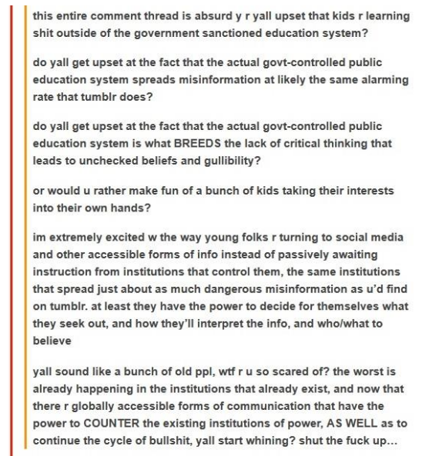
Figure 1.

In this figure, we can see how young people are engaged in a discussion about a serious topic. The discussion, however, began on Twitter but it was taken on Tumblr and there, young people gave their opinions. Twitter is known to be used by all age groups, while for Tumblr it is not the case. The original post that was taken from Twitter went:
“im extremely excited w the way young folks r turning to social media and other accessible forms of info instead of just passively awaiting instruction from institutions that control them”
It might seem wrong to assume that young people spend their time on the Internet only for the sake of their entertainment, discussions about serious topics like this are often seen on Tumblr. This is only one of many. Some of the language deviations we can see in this discussion are the abbreviated forms of words and expressions and acronyms which would be one of the most commonly used forms on Tumblr. Here we can say how young people are using those linguistic deviations to belong to social groups, i.e to belong to Tumblr society. Furthermore, punctuation in this discussion is used, but not the standard-based punctuation, and we can see how Tumblr users are using other features together with the language to convey the message they want to in a better manner. Another important thing we can notice is the capitalization of the letters, which further shows how the language used on Tumblr is not used by itself. The entire discussion is emotionally loaded, which we can see from the explicit language and other strongly positive or negative reactions beyond their literal meaning. This shows the importance of how language is used and how language is always in the world. If a discussion about this is held on a national TV channel or a political debate, this emotionally loaded and explicit language would not be used, but because this is on a social network used mainly by young people and from anonymous people, instances of this language are found quite often. In this figure, we do not have specific examples of language ambiguity. In the following sections, all these instances mentioned previously will be analyzed separately and more in-depth.

  - Language is ambiguous
Aside from vocabulary developed for new technologies and the technological character of the medium, such as blogger, Tumblogger, gif, or posts, new expressions and words make up the majority of the new lexicon on the Internet. Methods that are most common for creating new lexicon on the Internet are abbreviations and acronyms, as it was discussed in the previous section. Although we have seen some methods for creating new vocabulary, one of the most noticeable ‘methods’ seen on Tumblr is how people are taking advantage of the ambiguity of language. We know that the meaning of language is not always clear. Occasionally, what is meant to be said is not said and what is said is not meant (Jones, 2009). This has been exploited by Tumblr users, and they have converted many words that have the conventional meaning into something completely divergent.
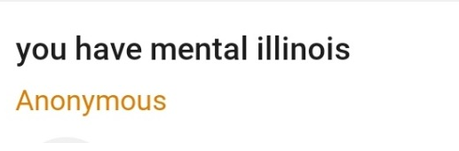
Figure 2.

Tumblr-Internet-Speak is not always as indolent and lethargic as it seems. New vocabulary (phrases and expressions) is made from existing words but, more often than not, the conventional meaning of those words is repudiated and given a completely different or a similar meaning. As figure 5 shows, the name of the US state is used instead of the word “illness’’, which creates a rather funny and interesting expression used by Tumblr users. Illinois and illness are two different words, but on Tumblr, they can mean two things – which shows that language on Tumblr is ambiguous.
“I have lost all the ability to can” – a playful spin on the expression frequently used on the Internet “I can’t even.” Some other explanations for this expression could be that the person thinks that something is so amazing that they have lost their ability to express their appreciation for it in fully formed sentences, and all of the amazement by a certain item has been reduced to this ill-formed sentence.
“Right in the feels.” – another phrase formed on Tumblr-Internet and it expresses many emotions, can be used in both positive and negative contexts – which again shows how language on Tumblr is ambiguous.

3.3. Language Is Always ‘in the World’
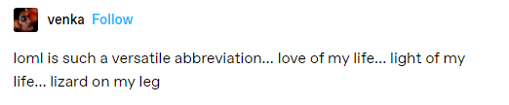
Figure 3.
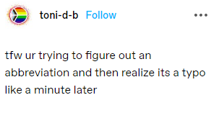
Figure 4.

Informal writing consists of short sentences, and it is used in much more personal settings and is done in a more relaxed manner. One of the main informal writing properties and key features is contractions, abbreviations, and acronyms. What differs on Tumblr and other social networks is that on Tumblr this type of writing is found most often. Additionally, this is a standard on Tumblr, unlike on other platforms. What language means is a matter of where it is found, when it is used and what it is used to do (Jones, 2019). Some of the most frequent abbreviations and acronyms are:
- gg = girl group
- bg = boy group
- stan = a big fan of a certain group. Eg. “He is such a Queen stan.”
- oof = that sucks
- pfp = profile photo
- bop = it’s good song
- tfw = that feel/feeling when
- locals = people who dislike korean music and like to insult bands and fans
- choreo = choreography
- mv = music video
- ent. = entertainment
- concept = theme of that album/era
- i-fans = international fans
- k-fans = korean fans
- cb = comeback
- fandom = the fans of a certain group
- ayego = cute actions or sayings performed by someone
- streaming party = when multiple fans watch one mv multiple times to gain views
- saesang = crazy stalker fan
- POV - Point Of View. The view of which something is being written or read from. Eg. "This is written from Sarah's POV."
- Canon - Something that is not (confirmed) true; rumor. Eg. "That is not canon!"
- Y/N - Your Name. Typically used in writing when the author is writing something that is interactive from a reader's point of view. Eg. "Y/N decided it was best we didn't follow through with Carl's plans."
- NSFW - Not Safe For Work. Used to describe a piece of writing or a video of some sort that involves sexual themes, or other disturbing content. Eg. "Chapter three is NSFW, so please read with caution."
- SFW - Safe For Work. Used to describe something that is (typically) safe for all ages. Eg. "This is very SFW, don't worry."
- Smut - Another word for sex, or sexual themes. Eg. "This will contain a lot of smut, so strictly 18+ please."
- Anon - Short for 'anonymous'. When someone sends an anonymous ask or submission, they are referred to as Anon. Eg. "Thank you for the ask, anon."
- OTP - One True Pairing. Generally refers to a pairing that someone ships above everything else. Eg. "I can imagine my OTP doing this."
- SK – Stop Keying. When you want someone to stop texting you.
- Sksk – hang up now. Sksk or SK SK is used when you want to hang up a phone call.
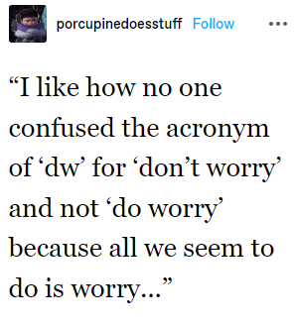
Figure 5.
  - The way we use language is inseparable from who we are and the different social groups we belong to
Previous research has established how Tumblr is an important platform for the LGBT community, especially among transgendered youth. This platform has seen the birth of different terms used for the description of sexual orientations, gender identities and such. By using those terms, in Tumblr community, you can immediately see what you support or do not, and certain terms have been coined for people who support or do not support transgendered people. On Tumblr, the division has been created between two social groups: transmed truscum and anti-transmed tucute. The first social group, transmed truscum, or transmedicalist, refers to a group of people who see trans identity as a medical diagnosis. Truscum is a combination of true transsexual and scum, and it is mostly used as a derogatory term. The second social group, anti-transmed tucute, rejects the medical model of transness, they accept body autonomy and self-definition and include non-dysphoric and non-binary individuals as trans too. The term tucute comes from the expression ‘too cute to be cis’. The term Transtrender also appears in connection with anti-transmed and tucute people, and it suggests that these are people who are cisgender but are pretending to be trans just to get attention.
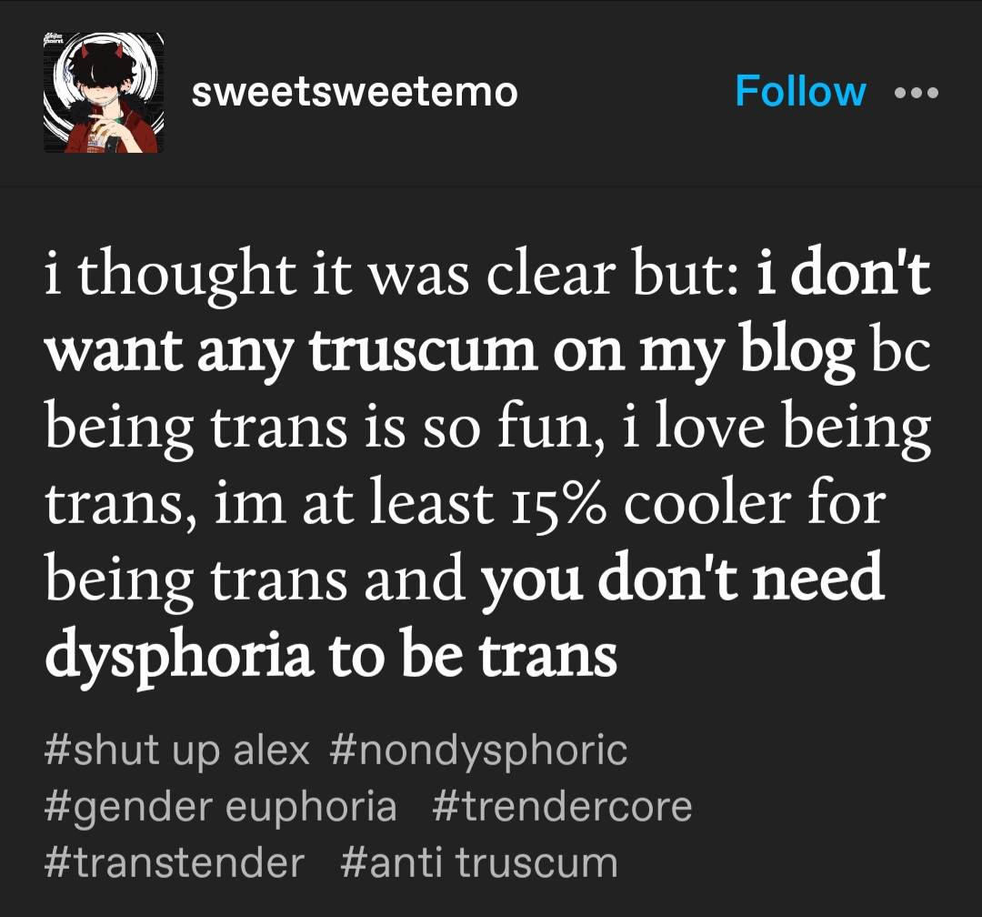

Figure 6.
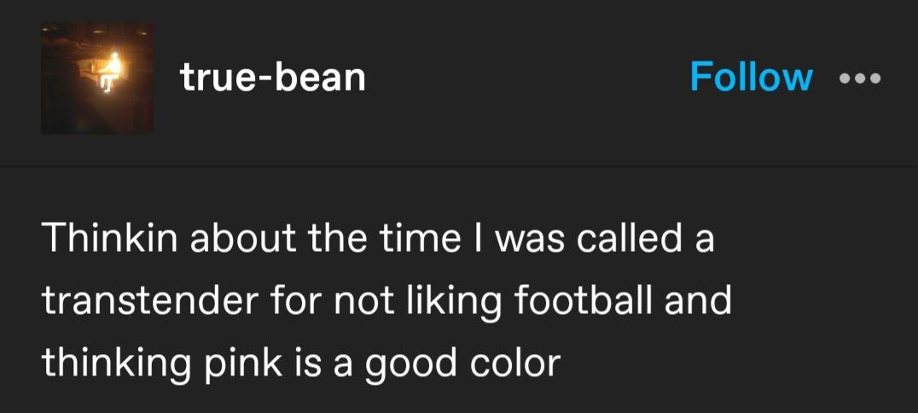
Figure 7.

  - Language Is Never Used all by Itself
Non-standard use of punctuation is quintessential in Tumblr posts/blogs. In agreement with Peterson’s (2011) description of punctuation in the Internet register, these features aim to express emotions in a computer-mediated communicative situation, in which it is not possible to maintain face-to-face interaction. In other words, non-standard use of punctuation adds tone, intensity, reactions, and facial expressions to texts on Tumblr. It creates a semi-speech - between speaking and writing - with its features, which is a characteristic of electronic/internet discourse. (Abusa’aleek, 2015). Another property of Tumblr texts is no punctuation. At other times, the standard punctuation is substituted by some other because it might be considered to be aggressive rather than neutral like it is the case with a full stop (.). In addition, Tumblr users also tend to over-use certain punctuation marks to express their confusion (e.g. “???????”), excitement or frustration (e.g.”!!!!!!!”)
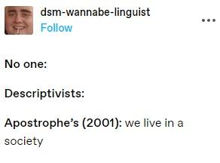
Figure 8.

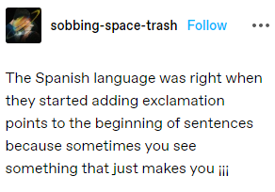
Figure 9.

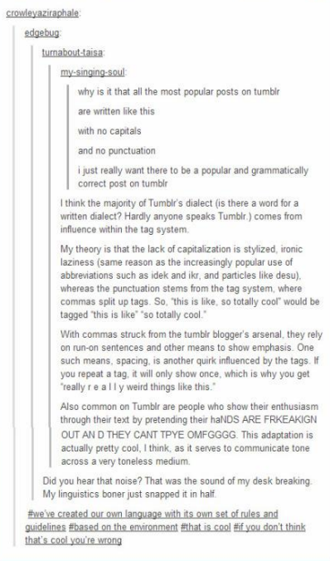
Figure 10.
Although this seems rather lethargic and “confirms” the generally accepted fact that teenagers are lazy and often want to break the rules, as is the case with grammatical rules as well, this can be an instance of something else. Excluding all the punctuation functions as the tone of rhetorical speech, and it confirms that language is never used by itself. In essence, no punctuation is punctuation, in view of the fact that not including punctuation on a blog implies a specific ranting tone designed to mimic rhetorical speech. Alongside the lack of punctuation that adds a specific tone, in order to additionally reinforce or clarify the meaning of the language used, Tumblr users add emojis in theirs posts.

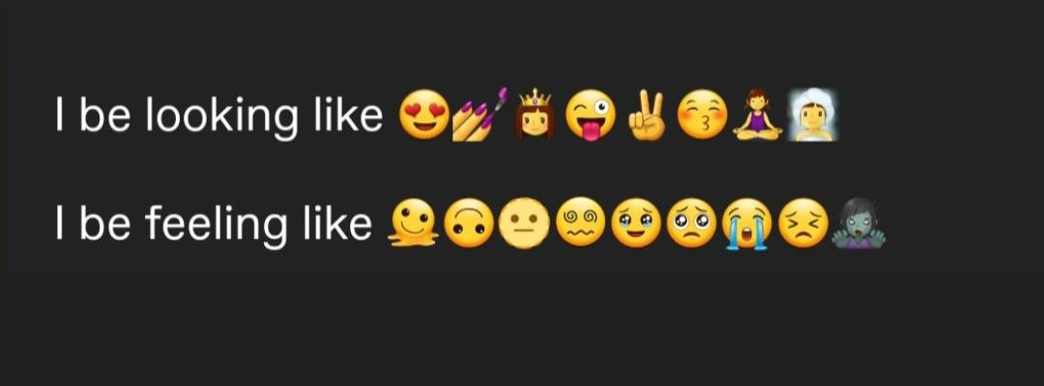
Figure 11.
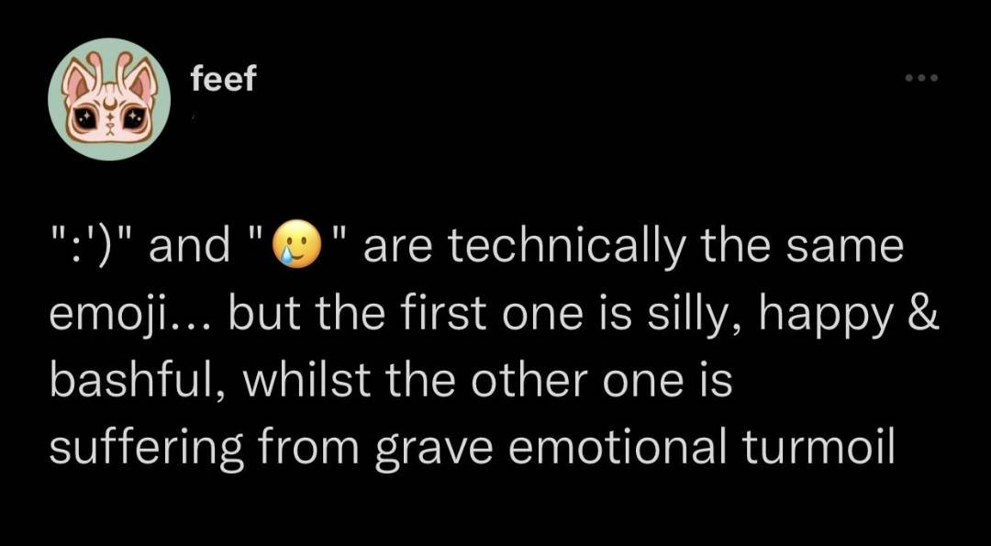
Figure 12.

- Conclusion
Tumblr is a highly informal and personal microblogging social media network that is used by teenagers and young adults. The language used on Internet has changed the standard forms of language as we know it, and a new branch of the academic field has developed just to analyze it (Crystal, 2011). This is an interesting linguistic phenomenon because Internet and Tumblr users are inventing new words, phrases and expressions constantly. However, this new language does not dominate the Internet world, but only those websites and informal social networks. This Internet language is used in everyday conversations, which shows how much impact the Internet has. Throughout this research, it can be seen how the linguistic deviations and ‘grammatical incorrectness’ have their meaning. The first assumption about the language – i.e. its ambiguity – is used as a way of coining new vocabulary, because as it has been mentioned, language does not always have a clear and conventional meaning, especially on Tumblr. Abbreviations are widely used in blogs/posts on Tumblr, and this covers the second assumption of the language – that is always in the world. It is a matter of where it is used, how and for what, and for Tumblr posts the abbreviations and acronyms are somewhat a standard, and it is being transferred to the spoken interaction as well. As of the third assumption – that language is inseparable from who we are and the social groups we belong to – we have seen how Tumblr users are usually divided into two groups and how, based on what group you belong to, you use different vocabulary, coin new term and through that, one can see what you support or do not support. Spoken interaction is significantly different from written interaction, with the advantage of seeing emotions and expressions. Tumblr users do not use language by itself – which is our fourth assumption - what Tumblr users use for adding a tone, intensity and ‘facial’ expression effect to their texts is the non-standard usage of punctuation. Over-use of punctuation marks functions as expressing either excitement, confusion, or frustration. No punctuation functions as a specific tone to imitate the rhetorical speech. Additionally, emojis are used to furthermore strengthen or define the meaning of said words. On a blogging platform, a group of teenagers and young adults changed a millennium-and-a-half-old gap in our language to match their language demands. For these new regulations, this group has decided on a more or less universal standard that fulfills the notion of "language."

- References
- Abusa’aalek, A. Internet Linguistics: A Linguistic Analysis of Electronic Discourse as a New Variety of Language. (International Journal of Linguistics, 2015).
- Chambers, J. K. Sociolinguistic Theory: Revised Edition [2nd ed.] (Chichester: WileyBlackwell, 2009).
- Crystal, D. Language and the Internet. (Cambridge: Cambridge University Press, 2006).
- Crystal, D. Internet Linguistics: A student guide. (Oxon: Routledge, 2011).
- Dawn Marie Murphy, Becky Spencer. "Teens’ Experiences with Sexting: A Grounded Theory Study" (Journal of Pediatric Health Care, 2021)
- Grant, H. (2015). Tumblinguistics: innovation and variation in new forms of written CMC
- Kretzschmar, Jr., W. A. The Linguistics of Speech. (New York: Cambridge University Press, 2009).
- Page, R., Barton, D., Unger, J.W., Zappavigna, M. Reseearching Language and Social Media: A student guide. (Oxon, Routledge, 2014, p.1.)
- Peterson, E. E. (2011). How conversational are weblogs? Language@Internet, 8.8, 1-18.
- Randall, N. (2002). Lingo online: A report on the language of the keyboard generation. Retrieved from http://www.arts.uwaterloo.ca/~nrandall/LingoOnline-finalreport.pdf
- Villares, R. (2017). A Corpus-based Analysis of Non-Standard English Features in the Microblogging Platform Tumblr (pp. 295-303)
- Jones, R.H. (2012) Discourse analysis, a Resource Book for Students, London and New York: Routledge.
- Jones R.H.(2019) Discourse Analysis, a Resource Book for Students, 2nd Edition, Abingdon: Routledge.

