TOWARDS A CULTURAL QUARTER: THE CASE OF MARIJIN DVOR

Lejla Odoabsic Novo¹, Adnan Novalic¹, Maja Popovac²
¹International Burch University, Sarajevo, Bosnia and Herzegovina
² University of Džemal Bijedic, Mostar, Bosnia and Herzegovina

lejla.odobasic@ibu.edu.ba
adnan.novalic@ibu.edu.ba
Maja.Popovac@unmo.ba

Abstract - Urban development and regeneration that is powered by the idea of culture has become a norm and part of legislation in most European cities since the 1990’s. This notion has been encored on the development of the ‘Creative City’, a concept envisioned for the new creative class based on the creative economy. The Creative City approach encompasses a holistic strategic development framework that is often characterized by the insertion of new cultural buildings (most typically museums) in the post-industrial zones or neglected neighborhoods. It often results in the design of cultural quarters, and the adoption of city branding strategies based on reductive images of the city as a cultural site. This paper takes on the idea of developing a Cultural Quarter as the first step towards developing a strategic plan for the transformation of the post-conflict Sarajevo and making it part of the European Creative City Network. It takes on Montgomery’s principles of the museum cultural districts and examines the potential of this proposal through Canter’s model for Metaphor for Place.

Keywords: Creative City, Cultural Quarters, Museums, Urban regeneration, Sarajevo

- Introduction

The concept of the ‘Creative City’ has gained significance during the last fifty years, because the of the economic structure shift that took place in Europe [1,2,3,4]. The economy has changed from an industrial, manufacturing-based one to a post-industrial, service-based, with significant after effects. The shift of industries from Europe and North America to Asia since the 1990’s, has caused a shutdown of more than 50 % of the factories [5]. As a result, this has left many postindustrial zones in numerous major cities across Europe and North America that need revitalization in order to preserve or improve the quality of urban living conditions. Since Europe was the leading player in setting up the standards of the industrial age, it now needs to invent a new basis for its development. According to present-day economists, rather than focusing on low cost manufacturing and services, it has to build upon knowledge and innovation, with strong social and environmental concerns [5].

In this context, all cultural activities and especially what can be called the “creative industries” could be used as a powerful engine to drive Europe forward and help its citizens meet the challenges of globalization. Creative industries play a key role in the shift towards a knowledge based economy [1]. This is true both directly (as important knowledge activities in their own right) and indirectly (by establishing a ‘climate of creativity’ that will generate innovation in other economic sectors). Thus many European cities have raised their awareness in terms of the cultural aspect that forms their identity and have started to invest in its development. Cities like Berlin, Paris, London, Amsterdam or Milan are embracing the creative economy and use it to complement their traditional role as centres of culture and creativity [6].

The above mentioned notion and the subsequent success of a Creative City concept has led academics, professional planners and policy makers to explore whether the creative city can be planned. However, the conclusions are that a Creative City cannot be planned per say, that in fact, no city as a whole is or can be creative or not. Each case requires analysis of existing conditions and a strategy based on those [5]. Thus the conclusion would be that the appropriate policies in place would also set up a good framework for creative industries to thrive. It is important to note that Creative Cities are comprised of different elements and span multiple scales. As such many different players and factors can contribute in its development [7].

For example, urban development policies can facilitate conditions for development of cultural institutions and events that could be enjoyed by residents as well as tourists or it can provide attractive locations for new iconic cultural infrastructure. Local economic development agencies, on the other hand, can contribute by shifting their focus on local creative industries and supporting the local creative economy [8]. Cultural managers and political bodies, that are responsible for cultural development in a city, can point to the need for investment in local cultural infrastructure and they can also support cultural events and activities. In addition, they can point to economic importance of the local cultural capital. However, all these steps require a long term strategy that would allow it time to come to fruition. Just like with any other large scale policy, short-term results are not viable as implementation takes a certain time frame, this is especially true when it comes to creativity as it is deeply rooted in multiple scales, spheres and histories [9].

Introducing the idea of the Creative City in Sarajevo as a means of regeneration and formation of its contemporary identity, is a long term process that will require multitude of scales, factors and players involved. Based on its rich cultural history, Sarajevo does have the potential to become a Creative City in the future. However, the issues which are rooted in the structure of the local governing system and policy making, prevent the development of a strategic or any kind of plan for cultural development. The current governing system cannot finance and sustain existing cultural institutions let alone organize a multidisciplinary effort and teams of participants from governmental and private sectors including researchers, economists, investors, creative directors, policy makers and ordinary citizens. At this moment the logistics are not in place for such a plan. For this reason, the paper proposed starting on a smaller scale of creativity by developing a strategy for the development of a Cultural Quarter for the city of Sarajevo. The creation of a successful Cultural Quarter could be a strong starting point for the formation of Sarajevo as a Creative City further down the line once the political structures are ready and in place.

1.1 Cultural Quarter as the first step towards Creative City

John Montgomery, internationally recognized town planner and urban economist, has specialized over many years in the cultural quarters, creative industries, economic development, arts strategy and place-making within the fields of economy, culture and design of cities He sees the concept of the cultural quarter in itself as an approach to urban regeneration [10]. Montgomery has categorized the different kinds of cultural quarters characterizing them in accordance to the policy objectives of making their designations. He has made a series of studies on the approach to ‘making’ places which are deemed to be artistic and cultural in the broader senses of the word, and has developed the methods and mechanisms for implementation as well as their ongoing management. The following are the four categories of cultural districts according to Montgomery:

1. Museum cultural districts (e.g. Museum Quarter in Vienna, South Kensington in London, Adelaide’s North Terrace)
2. Institutional cultural districts - a cross-over of the above with major performing arts institutions (London South Bank, Melbourne South Bank)
3. Metropolitan cultural districts - where cultural venues in the main are part of a dynamic urban mix (Temple Bar in Dublin), and these include smaller and medium-sized elements
4. Industrial cultural districts - centres of production both for the plastic arts and the creative and design industries (Sheffield’s Cultural Industries Quarter - CIQ, London’s cultural clusters and Tilburg in Holland) [10].

In addition, Montgomery argues that the museum cluster as well as an institutional cultural cluster, are both positive strategies that implement the historical and cultural ties to the consumption of culture. While he sees the metropolitan culture district more related to urban policy and zoning delineations and the industrial cultural districts he relates to the notion of economy and generation of culture as a way of progressing new work and employment.

As such this paper will propose a Cultural Quarter strategy developmet for Sarajevo based on Montgomery’s Museum Cluster Districts description. Since there is an existing museum cluster that is already present at Marijin Dvor (Historical Museum, National Musuem and future Ars Aevi Museum) this neighborhood lends itself to the formation of a fully developed Cultural Quarter. A few examples of cities with Museum Cluster Districts might be Berlin, Vienna and Frankfurt. Although, these quarters might seem like they have emerged randomly in unexpected areas of the city, they do in fact, have a long history. What is new, however, is the use of cultural quarters as a strategy for urban regeneration and redevelopment. In the following sub-section we shall examine the strategies in which this could occur at Marijin Dvor for the urban regeneration that would foster the notion of new Bosnian identity rooted in culture.

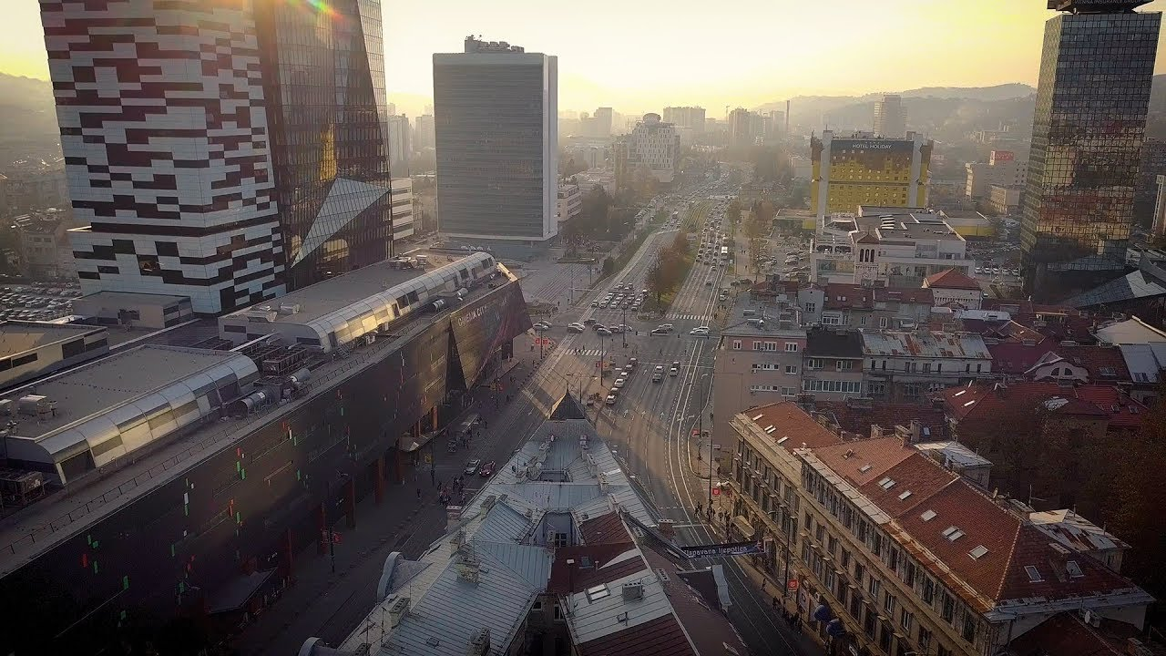
Figure 1. View of Marijin Dvor (source www)

- Materials and Methods

2.1 Defining a Cultural Quarter

Although, much like in the case of the Creative City, a creative quarter does not have a formula or a singular recipe. It is based on the existing conditions that are individual for each city [10]. As such, the museum quarter will in rooted in a more fluid a model, one developed in the late 1970 by Canter in the Metaphor for Place where he concluded that in order for an urban place to be successful it needs the following three elements:

1. Activity—economic, cultural, social;
2. Form—the relationship between buildings and spaces;
3. Meaning—sense of place, historical and cultural.

This paper will identify the existing elements and identify those that need improvement in order to develop Marijin Dovor into a Cultural Quarter. Designation of such quarters encourages both consumption and production of culture or a mixture of both. As such the paper will take into consideration Marijin Dvor as a case study and examine it through Canter’s model Metaphor for Place that consists of three parts: activity, form and meaning

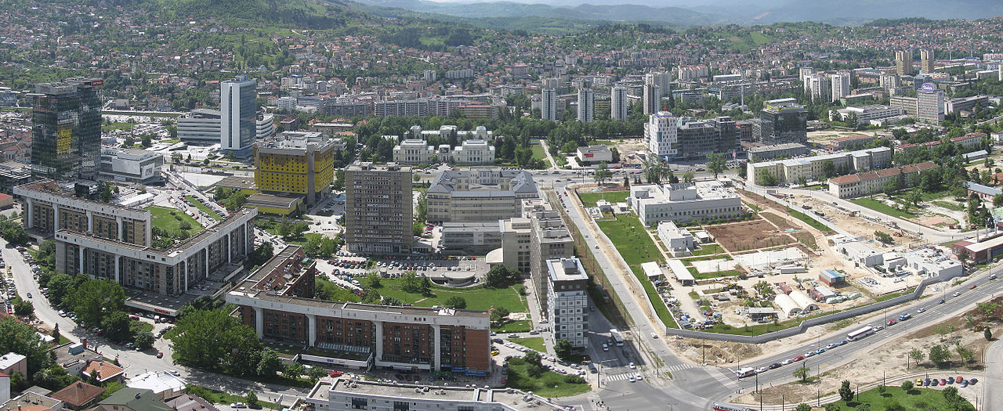
Figure 2. View of Marijin Dvor (source www)

2.2 Activity

The very first element that needs to be present in any cultural quarter is the cultural activity. It would be preferred that this activity includes both production and consumption of culture. That means that the involvement of cultural industries and occupations needs to happen as well as visitors who will participate in the process. Therefore, without cultural activity the cultural quarters could not exist. In order to generate a vibrant street-scape, it important that within the cultural activity to also have variety. This variety should encompass both the scale as well as the mixed economies that function during the day but some also in the evenings. Often the cultural quarters create a network of such venues, as seen in the example of Vienna Museum quarter, and the network acts as a regenerator in the wider urban scale that extends beyond the quarter itself.

2.3 Built From

Many urban theorists have written about the relationship of built form to the urban environment among which the pioneers in the field are Jane Jacobs and Kevin Lynch [11,12]. It is upon these writings that the criteria for built form has been constructed. There are a variety of features that influence the character of a quarter. In her work, Jane Jacobs summarizes them as a mixture of primary uses, intensity of the built form, permeability, and a mixture of building types, ages, sizes and conditions [11].

Urban grain plays an important role in the notion of built form, where a tight urban grain provides for a livelier street-scape. Another important factor is the quantity and quality of public space present in the area. In cultural quarters the public space tends to be more active and varied than in the remainder of urban scape. The public realm is not only a gathering space but it performs a variety of other functions. Montgomery summarizes those functions as:
• an integral part of the built form or town-scape;
• neutral territory where everyone has a right to gather;
• places where historical events occurred, and collective memory resides;
• places where public forms of social life can occur [10].

2.4 Meaning

Urban landscapes obtain meaning through historical events that layer over time, as well as individual and collective memories associated to it. In other words, the elements of the urban scape need to have a strong legibility in order to leave an impression on individuals and thus add meaning to the experience. This is no different for cultural quarters. Kevin Lynch referred to paths, nodes, landmarks, edges and districts as the defining elements of a city [12]. But it is the human experience of these elements that creates a mental map and inscribes meaning upon the urban space. This shapes how we experience the urban scape but also how we remember of form an image of it. There is also an associative element related to this process where we assign meaning to a place based on the events that took place there. This could be an individual experience or a collective one. As such, cultural quarters due to the amount of activity and venues are more likely to enable this process. This could also happen within a singular building and at times revitalization of a new building with a new function help carry a sense of history of that place.

3. DISUSSION

3.1 Activity present in Marijin Dvor

3. 1.1 Diversity of primary and secondary land uses

Marijin Dvor is one of the most diverse neighborhoods in Sarajevo when examining its Land Use. The area contains a good balance of residential, cultural, administrative, commercial and educational uses. Montgomery calls for a variety in primary land uses, including residential but he also suggests proportions of locally owned or more generally independent businesses, particularly shops. Although, Marijin Dvor does have a diverse land use, it could benefit more from a variety of small independent shops and street markets that would support the arts. Currently the shops are predominantly large corporation based and are concentrated in the three shopping malls in the area: Alta, Importance and Sarajevo City Centre. The arts are not well represented or featured in these spaces.

3.1.2 Extent and variety of cultural venues and events

There is a strong presence of the two existing museums in the area as mentioned above, the National Museum and the Historical museum with future plans for the Ars Aevi Musuem. However, there is not a variety of other cultural venues in the area. According to the Regulatory Plan issued by the Canton Sarajevo (http://zpr.ks.gov.ba/), a concert hall was planned in the area behind the current Sarajevo City Centre (SCC) shopping mall. An architectural competition was held but no winners have been announced and thus concert hall remains unbuilt.

This area could benefit from an introduction of other cultural and meeting places that could offer service of different kinds at varying prices and degrees of quality. This would ensure that more people -- other than the museum goers- are able to participate in the cultural scene of the area. These places could include the new concert hall but also smaller music venues, cinemas both indoor and/or outdoor, community theatre and smaller galleries. It would also be important to add outdoor array of designed spaces, including gardens, squares and corners, to enable people-watching and other activities such as cultural animation programmes.

The most vibrant part of Marijin Dvor in terms of evening economy (aside from thre three shopping centers present) is the river front street named Wilson’s Walkway. This is a two lane vehicular street that takes on solely pedestrian character after 5 pm and on the weekends. Along Wilson’s Walkway there is a number of cafes, restaurants and pubs that animate the area in the evenings. This street is also a popular destination for evening strolls and hosts a number of small playgrounds for children.

The remainder of the area that includes residential, commercial, cultural and administrative functions tends to be quiet and inactive in terms of economy in the evenings. It would be good to introduce evening activities in the two museums and the spaces in between them. Also the schools and universities could become more active in supporting evening classes for the arts and further involving the younger population on both production and consumption of cultural activity.

    - Strength of small-firm economy, including creative businesses/industry

Marijin Dvor does not have a strong small-firm economy that includes creative businesses. The commercial parts, are predominantly the three shopping centres and banking/finance industries in the Unitic Towers. The remainder of the area is administrative (Parliament Building, US Embassy, UN building, etc.) and residential. There are individual business in the “Importanne Centar” and a small amount of independent shops along Zmaja od Bosne Street but not in the creative businesses. It would be very beneficial to introduce local artist studios, architectural offices, web designers, independent craftsmen, jewelry makers, graphic designers, small rehearsal studios, etc. to the area. This would strengthen the local small -firm creative economy.

    - Access to education providers

Within the area of Marijin Dvor there is the main campus of the University of Sarajevo as well as the Faculty of Philosophy and Faculty of Natural Sciences and Mathematics in the close proximity. There is also a technical high school in the area. Most of these facilities could be connected to the programs organized at the museums in the area. Classes and courses could be organized in the museums and these joint ventures could be beneficial for both the academic institutions as well as the cultural ones. Small creative businesses could be developed which could also provide part time volunteer or internship positions for the local students and hence foster a sense of civic duty through the involvement in the arts.

3.2. Built Form in Marijin Dvor

3.2.1. Presence of cultural buildings (museum cluster)

Museum cluster is naturally occurring in the neighborhood by proximity of the two existing museums in the area -- the National Museum and the Historical Museum- as well as the site for the future building for Ars Aevi. However, the public space and the cultural activities that could take place in between the three museums need to be further developed and better planned. They also need to act as a connective tissue between the main road --Zmaj od Bosne-- and Wilson’s Walkway and as such start acting as urban catalysts for the area.

3.2.2. Fine-grain urban morphology

According to Montgomery, urban environments which are best suited to the sort of active place a cultural quarter should be tend to have a radius of around 400 meters, buildings averaging around 5–8 storeys, with very few streets over 10 meters wide which includes sidewalks [10]. Marijin Dvor falls within general principles of this guideline with a few exceptions. The area’s size falls within the general 400m radius --extending slightly over horizontally and under vertically -- and most buildings fall within the 5-8 storey mark. There are a few exceptions to this such as the Parliament building, the Unitic Towers and the still empty commercial tower at the SCC. As far the street width is concerned, only the major artery --Zmaj od Bosne-- falls outside of the preferable 10 meter width. The remainder of the roads are less than that. However, the pedestrian connectivity within the road network could use improvements.

3.2.3. Variety and adaptability of building stock

Montgomery also argues that cultural quarters should also be permeable and provide scope for many trading opportunities at ground-floor level [10]. This is mainly due to the fact, as a general rule, that the life of streets and urban areas is longer than the life of individual buildings, while the life of buildings is longer than the life of their original function. By extension, the successful urban area of varying kinds. There are a variety of building forms that offer much adaptability [13], and most of them tend to be buildings on several floors with a mixture of room sizes on each floor is one which offers in-built adaptability rather than in-built obsolescence. Again, this is especially true of places that contain a high proportion of small businesses of varying kinds. This is the area in which Marijin Dvor needs improvement. Although ground floors of some of the existing buildings are used for commercial purpose, this is not utilized to the fullest potential. There needs to be a better placement of small and varying kind of cultural business introduced into the area and into the existing fabric.

3.2.4. Permeability of street-scape

The success of urban quarters to a large extend could be judged by their street life. Good streets need to be active, to accommodate and generate diversity, and they must be permeable [10]. They also have well-defined edges and a quality of transparency or visibility at their edges where the private and public realms meet. Marijin Dvor has many ‘unresolved’ quarters that disrupt the permeability of street-scape. The area behind SCC for example has been designated for cultural use -- a new concert hall-- but currently is used as parking lot. Wilson’s walkway ends abruptly and the entire area behind SCC until Skenderija bridge is abandoned industrial buildings, illegal housing and parking lots. That area needs to be re-integrated into the quarter and revitalized. In addition the area along Wilson’s Walkway should have an improved permeability to the main road Zmaj od Bosne. The US Embassy is completely impermeable for security reasons while its security fence also provides a visual separation. University Campus is semipermeable with limited access, again due to security reasons.

As stated earlier, according to Montgomery, successful quarters will tend to have several such streets, or at least a number of activity nodes between which it is easy to travel between. Marijin Dvor does have Wilson’s Walkway and Zmaj od Bosne as the main activity nodes. However, these two streets need to have a larger variety of cultural activities and creative economies/industries. In addition to that the permeability in between them needs to be improved and enriched. Area north of Zmaj od Bosne across from SCC is predominantly residential zone withe commercial on ground floor along Zmaj od Bosne but again further into the fabric and into the internal courtyards of the residential buildings the permeability and ground level cultural activity needs to be improved.

3.2.5. Legibility

According the urban theorist Lynch legibility is the degree to which the different elements of the city (defined as paths, edges, districts, nodes and landmarks) are organized into a coherent and recognizable pattern [12].
Marijin Dvor is an area charged with nodes and landmarks but the degree of its legibility needs improvement. The different zones need better integration through a clearer and richer edge conditions that would be connected through more animated paths.

3.2.6. Amount and quality of public space

There is a great amount of public space available at Marijin Dvor but it has not been optimized and designed to capitalize on its cultural potential.

3.3. Meaning present in Marijiin Dvor

3.3.1. Important meeting and gathering spaces

Marijin Dvor is a very important area in terms of important meeting and gathering spaces in all areas of land use. Administrative: place where parliament building is situated with a large public space in front. It is a place of governmental gathering. There are also a number of embassies, such as US and Turkish as well as the UN headquarters. This makes the area of important international gathering. Below is a summary of gathering places which is based on building typology and grouped in the following categories: commercial, educational, sacred, recreational, residential, cultural as well as an additional category for trasnportaion..

Commercial: Three shopping centres ensure constant gathering of people in and outside of them. Also presence of Unitic towers and other financial institutions make it an important financial centre. Hotel Holiday Inn is an iconic building within the city and acts as a gathering space not only for tourists who stay there but also for conferences and meetings.

Educational: A number of faculties are situated in and around Marijin Dvor as well as a technical high school. This makes it an important gathering space of students and teachers.

Sacred: There is a large Roman Catholic church in the area where people congregate for mass and religious celebrations.

Recreational: Wilson’s Walkway has become a very important recreational gathering space. People stroll, jog, ride bikes and meet with their friends along it.

Residential: Most of the residential buildings which date from Austro-Hungarian period and as such are organized around the central courtyard, a semi-pubic gathering space. The residential buildings behind the Hotel Holiday Inn date from socialist era. They are designed in typical residential blocks from that era and encompass common spaces between the residential buildings.

Cultural: the two existing museums and hopefully the completion of Ars Aevi make a museum cluster and a very important cultural gathering spot for all ages.

Transportation: The tram passes along the main street Zmaj od Bosne St. and is the major public as well as vehicular transportation artery. Just to the north of Marijin Dvor, the railway and the bus stations are locate which connect Sarajevo to the remainder of the country.

3.3.2 Sense of History and Progress

This area used to be an ancient settlement of Zagorica but during the when the Ottomans arrived it was primarily a rural area occupied by only a few houses. Zagorica was later named Magribija, after a sheik who is deemed to have come from the Maghreb (a region of northwest Africa) and who built a house and mosque on this spot. The name “Marijin Dvor” means “Maria’s Palace” and is a residential building designed by the famous Czech architect Karl Paržik in 1885. During the Austro-Hungarian rule in BH, Paržik was one of the most esteemed architect who designed many of the most significant buildings during the monarchy rule. Marijin Dvor was built in stages until 1899, and was modelled on a typical Austro-Hungarian residential courtyard block. It consists of two stories of residential and one storey commercial use with a central courtyard in the middle. Positioned on the edge of the historic core of the city, Marijin Dvor was envisioned to become a new centre by the agency of the socialist regime. The Kingdom of Yugoslavia and the SFR Socialist Federal Republic of Yugoslavia added the following significant buildings to the area: the National Parliament and Executive Council building (for state institutions), the skyscrapers, UNITIC towers; the Faculty of Philosophy, Hotel Holiday Inn.

Today Marijin Dvor stands as an urban fragment that has acquired prominence through the fusion of disparate spatial manoeuvres of power in successive ideological eras. From its beginnings as an early modern real estate venture, the precise architectural articulation of this large crossroads started taking shape in the 1930’s with the erection of St. Joseph’s Catholic Church, continued in the 1970’s with the Parliament of the Socialist Republic of Bosnia and Herzegovina, and is recently being ‘complemented’ by the addition of a mixed-use out-of-scale buildings financed by a real estate development company based in Saudi Arabia. More recently, two shopping centers, Alta and Sarajevo City Center, have also gone up in Marijin Dvor, making this part of town the new center of Sarajevo. At the same time, it is here that you can encounter fragments of nearly every major period of Sarajevo history. The story of Marijin Dvor is really the story of one European city’s transformation throughout the centuries.

3.3.3 Area identity and imagery

The story of Marijin Dvor is really the story of one European city’s transformation throughout the centuries. As stated earlier, it has been envisioned by the Austro-Hungarian Empire as the new ‘western’ centre of Sarajevo. They built the National Museum in the area with the intent of later moving the governmental buildings the as well. This was carried out later through the socialist rule with the addition of the Parliament building, Unitic Towers and University Campus.

Throughout its modern history, Marijin Dvor has been the subject of Bosnian urbanists and intellectuals. The famous architect Neidhardt proposed a whole new vision for the area in the 1950’s. The ideas and structures of Neidhardt, the only paid assistant in the Paris studio of Le Corbusier — emphasized the integration of architecture and landscape, suggesting urban scenarios between utopia and pragmatism. Neidhardt’s sketches presented Marijin Dvor and Bašēaršija in relation to each other, despite being physically distant from each other and separated by the largest part of the city. To him, Marijin Dvor represented the demarcation line between old and modern Sarajevo.

3.3.4 Knowledgeability

Knowledgeability is about what makes a quarter unique or different than other places. This is also sometimes referred to as UPS or unique selling point. Developing this notion of a UPS helps to market and promote an
area. The marketing itself could take multiple forms, form word-to-mouth to tourist literature exposure. Events could also act as a very strong marketing tool for a neighborhood. Marijin Dvor has a great alternative citizen driven event that takes place in the previously mentioned half-moon area. The event is called “Mucha Lucha”. The event takes place in the buildings that have been completely destroyed during the conflict but now are given new functions and meanings. It is an unofficial social space where Sunday gatherings/ parties/bbq occur. On occasions concerts, talks or our events have taken place there as well. However, the buildings remain in ruins so events typically take place in the summer. It is a cultural squatting as the ownership is unresolved and buildings remain in ruins.

The area has also been attracting a lot of international press through the cultural appeal to save the Historical Museum. An exhibition has entitled “Sarajevo Now: People’s Museum” has been trying to raise awareness
about the deterioration of the building. The School of Architecture at the University of Sarajevo has often used this area as a case study. Unfortunately, despite all these important aspects and buildings the area still lacks a cohesive sense of identity. It still sits as multiple parts of different elements that have not found a unifying thread.

- Conclusion
This paper has used Canter’s model for Metaphor for Place in order to develop a strategy for a Cultural Quarter as the first step towards developing a strategic plan for the transformation of the post-conflict Sarajevo towards a European Creative City Network. Furthermore, based on Montgomery’s strategy for cultural district development, Marijin Dvor was used as the area of study due to the existing condition of naturally occurring museum cluster. After having applying the model for Metaphor for Place, it became clear that Marijin Dvor is a place of transition with diverse architectural styles that have added to its urban condition over time. However, it lacks a present-day architectural articulation of both urban elements as well as the architectural ones. It would be necessary to address this issue and over time introduce the design sensitivity that would be integral to the development of the cultural quarter.

- References

- Florida, R. (2014). The rise of the Creative Class. Print Basic Books, New York.
- Landry, C. (2009). The Creative City. Earthscan, London.
- Landry, C., and Franco B. (1994). The Creative City. 1st ed. The Round, Bournes Green Near Stroud, Gloucestershire, England.
- Yúdice, G. (2003), The Expediency of Culture: Uses of Culture in the Global World. Durham, NC: Duke University Press.
- Cohendet, P., Grandadam, D., Simon, L., (2010). “The Anatomy of the Creative City”. Industry and Innovation 17, 91–111. doi:10.1080/13662710903573869
- Howkins, J. (2001). The Creative Economy: How people make money from ideas. Penguin, London.
- Peter C. (2018) “Clarifying the Creativity Agenda: More Persistent Challenges”, Persistent Creativity, 235-273. Doi: 10.1007/978-3-030-03119-0_7,
- Sacco P., Ferilli G., and Blessi G. T., (2014). “Understanding culture-led local development: A critique of alternative theoretical explanations”, Urban Studies, 51, 13, (2806).
- Rodrigues, M., and Franco M., (2018). “Measuring the Performance in Creative Cities: Proposal of a Multidimensional Model”, Sustainability, 10.3390/su10114023, 10, 11, (4023), (2018).
- Montgomery, J. R. (1998). “Making a city: urbanity, vitality and urban design”, Journal of Urban Design, 3(1),
- Jacobs, J. (1970). The Economy of Cities. Published February 12th 1970 by Vintage (first published 1969)
- Lynch, K. (1981). A Theory of Good City Form. The MIT Press; First Edition edition.
- Bentley et al. (1985). “Responsive Environment, a Manual for Designers” (pp. 85-95). Oxford: Butterworth Architecture.
- Lynch, K. (1960). The Image of the City. The MIT Press. Cambridge, Massachusetts.
- Grabrijan, D., & Neidhardt, J. (1957). Arhitektura Bosne i put u suvremeno: Architecture of Bosnia and the way [towards] modernity. Ljubljana: Državna založba Slovenije.

