English Language as an Instrument Of Globalization

Amela Lukač Zoranić
International University in Novi Pazar, Novi Pazar, Serbia
prorektor.nastava@uninp.edu.rs

Fahreta Fijuljanin
International University in Novi Pazar, Novi Pazar, Serbia
fahretaf@hotmail.com

Abstract

World globalization establishes new standards for foreign language skills as well as for the teachers of foreign languages. Market globalization represents one of the main factors that influenced English language to be international language. In order to have a successful interaction between foreign companies, market and economy felt a need for the knowledge of English language. In this way English language became a device, an instrument of successful management and the most useful second language. There was also the need to improve knowledge of English language in every company and business institutions. Increasing the number of English language speakers, we increase the international communication in academic and business level.

Keywords: Globalization, English Language, Market, Business, Communication

Globalization is a term used to describe the changes occurring in our everyday lives and in society as well economy and politics resulting from international trade and cultural exchange. In economics the expression “free trade” was used prior to the term “globalization” to describe trade liberalization and deregulation on international market. The same term “globalization” nowadays is used in extended context, i.e. to describe all aspects of human existence. It is becoming increasingly difficult to ignore that:

Today's definition of the term comprise of factors that have contributed to globalization including increasingly sophisticated communications (in all levels), transportation technologies and services, mass migration and the movement of peoples and languages. It comes to define a level of economic, social and cultural activities that have outgrown national borders and markets through either industrial combinations and commercial groupings that cross national frontiers, international agreements that reduce the cost of doing business in foreign countries, or cultural influences of certain societies on others. (Wu & Dan, 2006)

Globalization enables interference of populations, cultures, languages within international borders as a result of the intensifying economic, social and cultural exchanges within different societies. Access to new technologies, media, internet an other medium of communication allow individuals global interactions with the belief that they frame intercultural communication.

There is no doubt that globalization intensifies worldwide social relations and consciousness of the world as whole and is considered as “fashionable buzzword” which can be adopted as a “concept referring to people’s groving consciousness of belonging to a global community.” (Steger, 2003:11).
According to Giddens “globalization is westernization or more specifically Americanization since western powers or the United States is now the sole superpower, with a dominant economic, cultural and military position in the global order [and] many of the most visible cultural expressions of globalization are American-coca cola, McDonald s and CNN.” (2000: 33).

Stager attempts to indicate that the term globalization applies to a set of social processes that appear to “transform our present social condition of weakening nationality into one of globality”. (2003:10) He explains that globalization is about shifting forms of human contact. In order to define and clarify the phenomenon of globalization Stager raises some questions like: How does globalization occur? What is diving globalization? Is it the cause or a combination of factors? Is globalization a uniform or an uneven process? How does globalization differ from previous social developments? (2003:11)

Stager believes that globalization is an uneven process, meaning that people living in various part of the world are affected very differently by this gigantic transformation of social structures and cultural zones. Nevertheless, when we speak about globalization, intercultural features the first language that comes to mind is English language.

It is noticeable that English is acknowledged by nearly all people as a result of their need to interact on an international scale. Anglo-America culture industry made English the global lingua franca of the 21st century. English is used in the economy, diplomacy, mass-media and education all over the globe in comparison with other languages which remained visible within national and regional frameworks.

The significance of the rise of the English language has a long history reaching back to the British colonialism and the attempt to subaltern the rest of the world as well to exploit and assimilate other cultures imposing English language as medium of communication between people. In 16th century, at the beginning of colonization only 7 million people used English as their mother tongue, by the end of the 20th century the number increased to over 350 million. “English was the official vehicle and the magic formula to colonial elite.”(Wa Thiongo, 2004:12).

In many colonized countries English has not been rejected as a symbol of colonialism, it has rather been adopted as a politically neutral language. Any achievement in spoken or written English was rewarded. English became the measure of intelligence and ability in arts, science, music, literature. English became the main determinant for the progress and the success in education and business.

Imperialism, led by the USA, presents the struggling peoples of the earth and all those calling for peace, democracy and socialism with the ultimatum: accept theft or death […] Biggest weapon wielded and actually daily unlashed imperialism against the collective defiance is the cultural bomb. The effect of cultural bomb is to annihilate a people’s belief in their names, in their languages, in their environment, in their heritage of the struggle, in their unity, in their capacities and ultimately in themselves. (Wa Thiongo, 2004:3)

Starting from the fact that “language serves as a symbol of group belonging enabling different groups of people to know what ethnic group they belong to and what common heritage they share”. (Kiplangat, 2003) Without language, people would lose their cultural identity, still the data pointing that English language is more used in some countries than native languages is concerning.

“The fact that absorption of the indigenous population by the colonisers has generally led to the loss of indigenous languages, especially when the colonised are kept in a subordinate position. The critical factor is their involvement in an economic system in which they must use the language of the new ruler in order to compete in the labour force and function adaptively. This is an aspect of globalisation as homogenisation, requiring that things work more or less the same way in the colony as in the metropole, especially in the exercise of power and control of the working class.” (Solikoko, p.29)

With globalization allowing languages and their cultures to spread and dominate on a global scale, it also leads to the extinction of other languages and cultures. Steger points out the decrease in number of spoken languages in the world. According to him there were 14,500 spoken languages in the world during 1500, to less then 7,000 in 2000. “Given the current rate of decline, some linguistics predicts that 50-90% of the currently existing languages will have disappeared by the end of the 21st century. (2003:84)
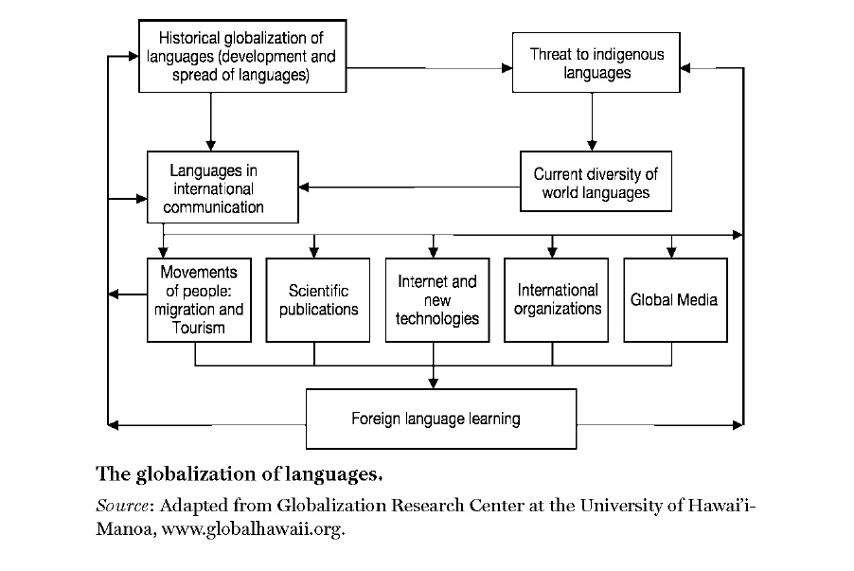
According to Anne Johnson along with the spread of the dominant language, the language's culture is also spread. This can be seen in popular American movies being shown globally, as well as American media and American food, such as in the globalization of McDonald's.

Proficiency in English has become a valuable commodity. Increases in global interactions over the past century have stimulated demand for more streamlined and efficient communication across lingual borders. Thus, in the business world, companies seeking to expand multinationally have had to find ways to communicate across such difference in cost-effective ways. Many firms have changed their corporate languages to the common tongue of English in efforts to streamline communication and avoid leaving team members. Responding to this situation, nearly a billion individuals worldwide are learning the language, most in hopes that their lingual skills will boost their paycheck or land them a better job. States, too, understand that an English-speaking workforce can help their economies integrate and become more competitive on the world market. (Johnson, 2009:132)

Anne argues that English language is seen as an imperialist and homogenizing force detrimental to the world’s cultural diversity, and then examine evidence to the contrary, which indicates that the English language is separating from its culture of origin and actually facilitating cross-cultural dialogue. (Johnson, 2009:136)

English is not only the language of the Anglo-Saxon nations but is the common language of many nations worldwide. It has been used in everyday life, in literature in all parts of human acting. Today, more than 80% content posted on the internet is English, leading scientific works are published in English. “in 1997, 95% of the articles indexed in the Science Citation Index’s Web of Science were written in English, despite the fact that only half were written by authors in English-speaking countries.” (Johnson, 2009:135) It has been noted by the researchers that publications written in languages other than English have a considerably lower impact than English-language works, and command lower compensation than works published in English.

It is believed that English language and globalization function as a pull factors for one another. Globalization could not happen in such a degree without development and vest usage of English language and at the same time globalization strengthen the position of English as a global language.

It is considered that global community can not function effectively without global language, therefore, as Crystal emphases: English is the language of globalization or “global language”. (Crystal, 1997)

Economic and professional incentives have made English an asset, “exportation of desirable technology often carries along the language and culture of the powerful manufacturer.” (Solikoko, 2002:33)

Whether it is a result of imperialistic plans of western powers over Europe or it is a natural consequence of globalization, it is certain that English is increasingly becoming popular in European media and education. It is been imposed that who has the knowledge of English doesn’t need other language in order to communicate with the rest of the world. “A language achieves a genuinely global status when it develops a special role that is recognized in every country.” (Crystal, 1997:3)

Is the dominance of English in scientific communication leading to a diglossic situation in continental European countries, a concomitant marginalisation of languages that hitherto have been extensively used in higher education and scholarly writing, with the result that competence in English is becoming a characteristic of elites, and we are moving towards an undemocratic division of linguistic labour since the rest of the population will be confined to a language in which much information is never available? (Philpson, 2000: 198)
According to Philipson the USA and UK have coordinated efforts to establish English as a ‘world’ language, and create the necessary professional infrastructure for achieving this since the 1930s. Crystal believes that British political imperialism had sent English around the globe, during nineteenth century.

A language has traditionally become and international language for one chief reason: the power of its people – especially their political and military power. During the twentieth century […] economics replaced politics as the chief driving force, and the language behind the US dollar was English. (1997:9-10)

In conclusion it is obvious that English language is a salient example of globalization. As stated by Schichao Li in her article, "Globalization of Languages," the English language can be considered a global language because "except English, no other language dominates international business, academia, media, the Internet, and international air/sea traffic." (2002)

English language became a device, an instrument of successful management and the most useful second language. On a daily basis, there is a constant need to improve knowledge of English language in every company or business institution, therefore the rising number of English speakers increases the international communication in academic and business level.

References

Cheruiyot, Kiplangat. (2003), "Our Languages are Dying", http://www.globalpolicy.org/globaliz/cultural/2003/0224language.htm
Crystal, David, (1997), English as a global language, Cambridge University Press, New York
Giddens, Anthony, (2000), Runaway World: How Globalization Reshaping Our Lives, Routledge, New York
Johnson, Anne (2009) "The Rise of English: The Language of Globalization in China and the European Union," Macalester International: Vol. 22, Article 12. http://digitalcommons.macalester.edu/macintl/vol22/iss1/12
Phillipson, Robert, (2000), “European language policy: An unmet sociolinguistic challenge”, Sociolinguistica, No. 14, 2000, p. 197-204.
Salikoko S. Mufwene, (2002), “ Colonization, Globalization, and the Future of Languages in the Twenty-first Century”, International Journal on Multicultural Societies, Vol. 4, No. 2, UNESCO
Shichao, Li, (2002), "Globalization of Languages", http://www.globalhawaii.org/PDF/language.pdf
Steger, B., Manfred, (2003), Globalization: A very short introduction, Oxford University Press, New York
Wa Thiango, Ngugi, (2004), Decolonizing the mind: the politics of language in African literature, Sunlitho ltd., Kenya
Wu, Li, Dan, Ben-Canaan,(2006), The Impact of Globalization and the Internet on
English Language Teaching and Learning, Heilongjiang University, School of Western Studies, Harbin http://www.academia.edu/188911/The_Impact_of_Globalization_and_the_Internet_on_English_Language_Teaching_and_Learning

